**Kingston University, BSc (Hons) (top-up)**

**Coursework Coversheet**

**Draft Coursework – Subject to Moderation**

**Part 1 - To Remain with the Assignment after Marking**

|  |  |
| --- | --- |
| **Student ID: KAN00217052** | **Student Name: A.A.M Aathif** |
| **Module Code:** | **Module Name: Programming - Pattern & Algorithms** |
| **Assignment number:** | **ESoft Module Leader:** |
| **Date set:2024/10/19** | **Date due: 2024/11/09** |

**Guidelines for the Submission of Coursework**

1. Print this coversheet and securely attach both pages to your assignment. You can help us ensure work is marked more quickly by submitting at the specified location for your module. You are advised to keep a copy of every assignment.

2. Coursework deadlines are strictly enforced by the University.

3. You should not leave the handing in of work until the last minute. Once an assignment has been submitted it cannot be submitted again.

**Academic Misconduct**: **Plagiarism** and/or **collusion** constitute **academic misconduct** under the University's Academic Regulations. Examples of academic misconduct in coursework: making available your work to other students; presenting work produced in collaboration with other students as your own (unless an explicit assessment requirement); submitting work, taken from sources that are not properly referenced, as your own. By printing and submitting this coversheet with your coursework you are confirming that the work is your own.

|  |  |  |  |
| --- | --- | --- | --- |
| |  | | --- | | ESoft Office Use Only:  Date stamp: work received | | |  | | --- | |  | |

**Kingston University, BSc (Hons) (top-up)**

**Coursework Coversheet**

**Part 2 – Student Feedback**

|  |  |
| --- | --- |
| **Student ID: KAN00217052** | **Student Name: A.A.M Aathif** |
| **Module Code:** | **Module Name: Programming - Pattern & Algorithms** |
| **Assignment number:** | **ESoft Module Leader:** |
| **Date set: 2024/10/19** | **Date due: 2024/11/09** |

|  |
| --- |
| Strengths (areas with well-developed answers) |

|  |
| --- |
| Weaknesses (areas with room for improvement) |

|  |
| --- |
| Additional Comments |

|  |  |  |
| --- | --- | --- |
|  |  |  |
| **ESoft Module Lecturer: Vikum Jayasundara** | **Provisional mark as %:** |  |
| **ESoft Module Marker:** | **Date marked:** |

|  |  |
| --- | --- |
| CI6115 Programming III - Patterns and Algorithms | |
| Weighting | 50% |
| Description | The aim of this coursework is to develop and document a software application using any Object-Oriented Programming (OOP) language and compatible tools of any version. The application can be either console-based or GUI-based and should address the specified case study. |
| Expected Deliverables | The submission must include the following three parts in a single document, along with all project files uploaded as a separate compressed folder:  **Class Diagram and Discussion**:   * A comprehensive class diagram for the proposed system. * Accompanying discussion that highlights the key design decisions and rationale behind them.   **Source Code**:   * Complete source code of the proposed system, demonstrating the use of:   1. Classes and objects   2. Object-Oriented Programming concepts   3. Data structures   4. Relevant algorithms   **Test Cases**:   * A full set of test cases used to validate the system. |

**Case Study**

**Aurora Skin Care** is a medium-scale, affordable private skin clinic situated in Colombo to provide dermatological services to out-patients who are unable to receive medical facilities from the expensive skin clinics. There are two dermatologists visiting the clinic and the available consultation dates and times are as follows:

* Monday: 10:00am - 01:00pm
* Wednesday: 02:00pm - 05:00pm
* Friday: 04:00pm - 08:00pm
* Saturday: 09:00am - 01:00pm

Note that one dermatologist requires a 15-minute session per patient, and the selection of the dermatologist is based on the patient's preferences.

The front desk operator is responsible for booking appointments for patients by scanning through doctors’ consultation schedules for the date(s) requested by a patient and then informing the patient of the available options. If the patient is satisfied with a specific appointment time, they can reserve the appointment for that date and time by paying a registration fee of LKR 500 and providing patient information such as NIC, name, email, and telephone number.

Once the patient has received the treatment, the final fee is calculated according to the treatment type. A 2.5% tax is added to the final amount, which is then rounded up to the nearest decimal number. The treatment types with fixed prices are listed below:

|  |  |
| --- | --- |
| **Treatment** | **Price** |
| Acne Treatment | 2750.00 |
| Skin Whitening | 7650.00 |
| Mole Removal | 3850.00 |
| Laser Treatment | 12 500.00 |

**The Proposed system should perform the following functions**:

1. Make appointments
2. Update appointment details.
3. View appointment details filtered by date.
4. Search for an appointment using patient name or appointment ID.
5. Accept registration fee when placing appointments.
6. Calculate the total fee and taxes for the treatments after the appointment.
7. Generate an invoice for the payment, clearly stating how the total was calculated.

**Further information and reminders:**

* **Class Diagram**: Use any standard UML tool to draw the class diagram. Ensure that the images are clear. Watermarks are acceptable if they are not obtrusive. **Each class name in the diagram must be prefixed with your Kingston University student ID, otherwise, marks will be deducted**.
* **Programming Language**: You may select any object-oriented programming language, but Java is preferable.
* **Frameworks**: Use frameworks with careful evaluation. If a framework generates all the classes for you, marks will be deducted.
* **User Interfaces**: User interfaces can be either Command Line Interfaces (CLI) or Graphical User Interfaces (GUI). Evaluate the user experience in terms of UI/UX for the chosen interface type. The choice of interface type will not impact grading; the focus should be on the quality of implementation.
* **Screenshots**: Include clear screenshots of the code and user interfaces, following the detailed instructions provided.
* **Test Cases**: Use a standard test case template. General testing procedures are sufficient; there is no need to follow higher standards or use automation mechanisms.

**Marking Scheme**

|  |  |  |
| --- | --- | --- |
| **Item** | | **Marks Allocation** |
| **Class Diagram (20)** | | |
| 1 | Identification of classes & objects | 05 |
| 2 | Application of objects, fields, and methods | 05 |
| 3 | Use of associations effectively | 05 |
| 4 | Sensible naming of programmer-defined variables, classes, properties, and methods | 05 |
| **Software Implementation (60)** | | |
| 1 | Completion of functional modules | 30 |
| 2 | Effective use of object-oriented programming concepts | 10 |
| 3 | Effective use of data structures | 05 |
| 4 | Effective use of algorithms | 05 |
| 5 | Use of Test Cases | 10 |
| **Programming Style (20)** | | |
| 1 | Clarity of code which shows the underlying algorithm | 05 |
| 2 | Sensible naming of programmer-defined variables, classes, properties, and methods | 05 |
| 3 | Useful comments in code | 05 |
| 4 | User interface design and usability of the system | 05 |
| **Total** | | **100** |

**Academic Integrity:**

Academic integrity means demonstrating honest, moral behaviours when producing academic work. This involves acknowledging the work of others, giving appropriate credit to others where their ideas are presented as part of your work and the importance of producing work in your own voice. Contributions by artificial intelligence (AI) tools must be properly acknowledged. As part of a learning community students share ideas and develop new ones - you need to be able to interpret and present other people's ideas and combine these with your own when producing work.

**Plagiarism (including copying, self-plagiarism and collusion)**

The act of presenting the work of another person (or people) and/or content generated by artificial intelligence (AI) tools as your own without proper acknowledgement. This includes copying the work of another student or other students. The University expects students to take responsibility for the security of their work (i.e. with written work, to ensure that other students do not get access to electronic or hard copy of the work). Failure to keep work secure may allow others to cheat and could result in an allegation of academic misconduct for students whose work have been copied, particularly if the origin of the work is in doubt.

**Self-plagiarism**

The act of presenting part or all of your work that has been previously submitted to meet the requirements of a different assessment, except where the nature of the assessment makes this permissible.

**Collusion**

The act, by two or more students of presenting a piece of work jointly without acknowledging the collaboration. This could include permitting or assisting another to present work that has been copied or paraphrased from your own work. The University also defines collusion as the act of one student presenting a piece of work as their own independent work when the work was undertaken by a group. With group work, where individual members submit parts of the total assignment, each member of a group must take responsibility for checking the legitimacy of the work submitted in his/her name. If even part of the work is found to contain academic misconduct, penalties will normally be imposed on all group members equally.

**Purchasing or Commissioning**

The act of attempting to purchase or purchasing work for an assessment including, for example from the internet, or attempting to commission, or commissioning someone else to complete an assessment on your behalf. The procedures for investigating suspected cases of academic misconduct are set out in Academic Regulations 6 Academic Integrity - Taught Courses 2023/24

**Acknowledging Generative AI in coursework**

Where generative AI has contributed to an assignment the following information should be included in the submission: A statement on the use of generative AI as part of the assessment, including the extent of use, and how it was used as part of all stages in creating the final submission, e.g., including planning, and generating ideas. This should normally be provided at the end of a written assignment with the heading ‘Acknowledgement of AI Contribution’. For other assignment types, module staff will advise on how this should be done.

**You must meet all deadlines set. Failure to do so will result in a penalty.**

Work submitted late but within a week of the deadline will be capped at 40% and receive a grade of LP (Late Pass) unless it is not of a passing standard in which case it will receive a grade of LF (Late Fail). Work submitted beyond a week of the deadline without approval will get 0% with a grade of F0. If, however, you have a serious problem, which prevents you from, meeting the deadline you may be able to negotiate an extension in advance. In the first instance you should contact the module team for advice. However, any extension will need to be formally agreed by the Faculty via the Mitigating Circumstances process, your work will then be marked without penalty.

**Table of Contents**

List of Figure 13

List of Tables 14

Acknowledgment 15

Activity 01 – System Overview and Requirements 16

1.1 Introduction 16

1.2 Requirements Analysis 17

1.2.1 Functional Requirements 17

1.2.2 Non-Functional Requirements 18

Activity 02 – System Design and Implementation 19

2.1 Class Diagram 19

2.1.1 How System Works Based on this UML Diagram 20

2.1.2 Class Overview 21

2.1.2.1 Aurora Skin Care 21

2.1.2.1 Person 22

2.1.2.2 Patient 22

2.1.2.3 Doctor 23

2.1.2.4 Schedule 23

2.1.2.1 Appointment 24

2.1.2.2 Treatment 25

2.1.2.3 Payment 25

2.1.2.4 Invoice 26

2.2 System Design 27

2.2.1 Main Menu of the Aurora Skin Care System 27

2.2.2 Patient Registration 27

2.2.3 Make Appointment 28

2.2.4 Update Appointment by Date, Time 29

2.2.5 View Appointment by Date 29

2.2.6 Search Appointment by Patient Name / Appointment ID 30

2.2.6.1 Search by Appointment ID 30

2.2.6.2 Search by Patient Name 30

2.2.7 Search Doctor 31

2.2.7.1 Search by Doctor ID 31

2.2.7.2 Search by Doctor Name 31

2.2.8 Search Patient by Name / NIC 32

2.2.8.1 Search by NIC 32

2.2.8.2 Search by Patient Name 32

2.2.9 Cancel Appointment 33

2.2.10 Generate Invoice 33

2.2.11 Invoice 34

2.2.12 Exit 34

Activity 03 – Implementation 35

3.1 The Implementation of the Aurora Skin Care 35

3.1.1 Main Program Class 35

3.1.2 Person Class 36

3.1.3 Patient Class 37

3.1.3.1 Register Patient Method 38

3.1.3.2 Search Patient Method 39

3.1.4 Doctor Class 40

3.1.4.1 Search Doctor Method 41

3.1.5 Appointment Class 42

3.1.5.1 Make New Appointment Method 44

3.1.5.2 Update Existing Appointment Method 46

3.1.5.3 View Appointment Method 47

3.1.5.4 Search Appointment by Patient Name / Appointment ID 48

3.1.5.5 Cancel Appointment Method 49

3.1.6 Treatment Class 50

3.1.7 Payment Class 51

3.1.8 Invoice Class 52

3.1.8.1 Generate Invoice Method 53

3.2 Effective use of Object-Oriented Programming (OOP) concepts 55

3.2.1 Encapsulation 55

3.2.2 Inheritance 55

3.2.3 Polymorphism 56

3.2.4 Abstraction 56

3.3 Effective use of Data Structures 57

3.3.1 Classes as Data Structures 57

3.3.2 Collections Framework 57

3.3.3 Encapsulation of Data 58

3.3.4 Use of Primitive Types 58

3.4 Effective use of Algorithms 59

3.4.1 Searching Algorithms: Searching for a Patient by NIC or Name 59

3.4.2 Data Manipulation Algorithms: Adding a New Appointment 59

3.4.3 Invoice Generation Algorithms: Calculating Total Amounts 59

Activity 04 – Testing & Conclusion 60

4.1 Black-Box Testing 60

4.2 Unit Testing: Test Cases for Aurora Skin Care 61

4.2.1 Patient Related Test Cases 61

Test Case 01 – Register New Patient 61

Test Case 02 – Search Patient by NIC 62

Test Case 03 – Search Patient by Name 63

Test Case 04 – Invalid NIC for Search 64

4.2.2 Doctor-Related Test Cases 65

Test Case 05 – Search Doctor by ID 65

Test Case 06 – Search Doctor by Name 66

Test Case 07 – Invalid Doctor ID 67

Test Case 08 – Invalid Doctor Name 68

4.2.3 Appointment-Related Test Cases 69

Test Case 09 – Make Appointment 69

Test Case 10 – View Appointment by Date 70

Test Case 11 – Update Appointment Details 71

Test Case 12 – Search Appointment by Name / Appointment ID 72

Test Case 13 – Cancel Appointment 73

Test Case 14 – Invalid Appointment Date 74

Test Case 15 – View Appointment by Invalid Date 75

Test Case 16 – Search Appointment by Invalid Appointment ID 76

Test Case 17 – Cancel Non-Existent Appointment 77

4.2.4 Payment-Related Test Cases 78

Test Case 18 – Calculate Total Amount with Tax 78

Test Case 19 – Generate Invoice 79

Test Case 20 – Generate Invoice by Invalid ID 80

4.3 Discussion: Key Challenges Encountered 81

4.3.1 NullPointerException when Accessing Patient / Doctor Information 81

4.3.2 IndexOutOfBoundsException in Treatment Selection 82

4.3.3 InputMismatchException in Main Menu Selection 83

4.4 Conclusion 84

4.5 Future Enhancements 85

Gantt Chart 86

References 86

# List of Figure

Figure 1 Class Diagram of Aurora Clinic Care System 19

Figure 2 CLI Snap 01 - Main Menu of the system 27

Figure 3 CLI Snap 02 - Patient Registration 27

Figure 4 CLI Snap 03 - Make Appointment 28

Figure 5 CLI Snap 04 - Update Appointment by Date, Time 29

Figure 6 CLI Snap 05 - View Appointment by Date 29

Figure 7 CLI Snap 06 - Search Appointment by Appointment ID 30

Figure 8 CLI Snap 07 - Search Appointment by Patient Name 30

Figure 9 CLI Snap 08 - Search Doctor by Doctor ID 31

Figure 10 CLI Snap 09 - Search Doctor by Doctor Name 31

Figure 11 CLI Snap 10 - Search Patient by NIC 32

Figure 12 CLI Snap 11 - Search Patient by Patient Name 32

Figure 13 CLI Snap 12 - Cancel Appointment 33

Figure 14 CLI Snap 13 - Generate Invoice 33

Figure 15 CLI Snap 14 - Invoice 34

Figure 16 CLI Snap 15 - Exit 34

Figure 17 Code Snippet 01 - Main Program Class 35

Figure 18 Code Snippet 02 - Person Class 36

Figure 19 Code Snippet 03 - Patient Class 37

Figure 20 Code Snippet 04 - Register Patient Method 38

Figure 21 Code Snippet 05 - Search Patient Method 39

Figure 22 Code Snippet 06 - Doctor Class 40

Figure 23 Code Snippet 07 - Search Doctor Method 41

Figure 24 Code Snippet 08 - Appointment Class 43

Figure 25 Code Snippet 09 - Make New Appointment Method 44

Figure 26 Code Snippet 10 - Update Existing Appointment Method 46

Figure 27 Code Snippet 11 - Update Existing Appointment Method 47

Figure 28 Code Snippet 12 - Search Appointment by Patient Name / Appointment ID Method 48

Figure 29 Code Snippet 13 - Cancel Appointment Method 49

Figure 30 Code Snippet 14 - Treatment Class 50

Figure 31 Code Snippet 15 - Payment Class 51

Figure 32 Code Snippet 16 - Invoice Class 52

Figure 33 Code Snippet 17 - Generate Invoice Method 53

Figure 34 Code Snippet 18 – Encapsulation of OOP Concept 55

Figure 35 Code Snippet 18 – Inheritance of OOP Concept 55

Figure 36 Code Snippet 18 – Polymorphism of OOP Concept 56

Figure 37 Code Snippet 18 – Abstraction of OOP Concept 56

Figure 38 Code Snippet 19 – Classes as Data Structures 57

Figure 39 Code Snippet 20 – Collections Framework of Data Structure 57

Figure 40 Code Snippet 21 – Encapsulation of Data of Data Structure 58

Figure 41 Code Snippet 22 - Uses of Primitive Types of Data Structure 58

Figure 42 Code Snippet 23 - Searching Algorithms 59

Figure 43 Code Snippet 24 - Data Manipulation Algorithms 59

Figure 44 Code Snippet 25 - Invoice Generation Algorithms 59

Figure 45 Error 01 - NullPointerException 81

Figure 46 Solution 01 - Null Check and Error Handling 81

Figure 47 Output 01 - Informative Error Message 81

Figure 48 Error 02 - IndexOutOfBoundsException 82

Figure 49 Solution 02 - Input Validation 82

Figure 50 Output 02 - Informative Error Message 82

Figure 51 Error 03 - InputMismatchException 83

Figure 52 Solution 03 – Try-Catch Block 83

Figure 53 Output 03 - Informative Error Message 83

# List of Tables

Table 1 Test Case 01 Patient - Register New Patient 61

Table 2 Test Case 02 Patient - Search Patient by NIC 62

Table 3 Test Case 03 Patient - Search Patient by Name 63

Table 4 Test Case 04 Patient - Invalid NIC for Search 64

Table 5 Test Case 05 Doctor - Search Doctor by ID 65

Table 6 Test Case 06 Doctor - Search Doctor by Name 66

Table 7 Test Case 07 Doctor - Invalid Doctor ID 67

Table 8 Test Case 08 Doctor - Invalid Doctor Name 68

Table 9 Test Case 09 Appointment - Make Appointment 69

Table 10 Test Case 10 Appointment - View Appointment Details by Date 70

Table 11 Test Case 11 Appointment - Update Appointment Details 71

Table 12 Test Case 12 Appointment - Search Appointment by Name / Appointment ID 72

Table 13Test Case 13 Appointment - Cancel Appointment 73

Table 14 Test Case 14 Appointment - Invalid Appointment Date 74

Table 15 Test Case 15 Appointment - View Appointment by Invalid Date 75

Table 16 Test Case 16 Appointment - Search Appointment by Name / Appointment ID 76

Table 17 Test Case 17 Appointment - Cancel Non-Existent Appointment 77

Table 18 Test Case 18 Payment - Calculate Total Amount with Tax 78

Table 19 Test Case 19 Payment - Generate Invoice 79

Table 20 Test Case 20 Payment - Generate Invoice by Invalid ID 80

Table 21 Gantt Chart 86

# Acknowledgment

I would like to express my sincere gratitude to **Mr. VIKUM JAYASUNDARA** for his invaluable guidance and support throughout this coursework. His insightful lectures and constructive feedback were instrumental in shaping my understanding of patterns and algorithms. I would also like to thank my family and friends for their unwavering support and encouragement. Their belief in me motivated me to persevere through challenges and strive for excellence.

I am grateful to my peers for the collaborative learning experiences and for sharing their knowledge and insights. Their contributions enriched my understanding of the subject matter. I would like to acknowledge the support of Kingston University and its staff for providing the necessary resources and assistance.

# Activity 01 – System Overview and Requirements

## Introduction

Aurora Skin Care is a medium-scale, affordable private skin clinic located in Colombo, designed to provide accessible dermatological services to outpatients unable to afford premium services at higher-end clinics. With a team of two experienced dermatologists and a schedule that accommodates various time slots throughout the week, Aurora aims to offer high-quality, affordable skincare.

The clinic offers a simple and efficient appointment system facilitated by a front desk operator who manages **Scheduling, Patient Data, and Fee Processing**. Patients can choose their preferred dermatologist and reserve appointments based on their availability. To secure their appointments, patients must provide basic identification details and pay a registration fee of LKR 500.

Aurora Skin Care’s services include a variety of standard treatments such as **Acne Treatment, Skin Whitening, Mole Removal, and Laser Treatment,** each with a fixed price. Upon completion of a treatment, taxes are applied to the final bill and rounded appropriately to provide clarity and transparency. The proposed system for Aurora Skin Care will manage **Appointment Bookings, Patient Data, Payments,** and invoicing, with an emphasis on creating an organized and user-friendly experience for both patients and clinic staff.

This project aims to develop a reliable software solution tailored to the unique needs of Aurora Skin Care, incorporating **Object-Oriented Programming Principles** to enhance the efficiency and scalability of clinic operations. The proposed system will streamline key functions such as **Appointment Scheduling, Patient Information Management, and Payment Processing**. By implementing robust features like **Search and Filter Options for Appointments**, **Automated Calculation of Final Treatment Fees with Applicable Taxes**, and **Detailed Invoice Generation**, the solution will provide a **seamless experience** for both the clinic’s staff and patients.

## Requirements Analysis

### Functional Requirements

1. **Appointment Scheduling**
   * Allow the front desk operator to schedule appointments by reviewing dermatologist availability on specific dates and times.
   * Enable patients to select preferred time slots based on their choice of dermatologist.
2. **Update Appointment Details**
   * Allow operators to modify appointment times or details if needed by patients or doctors.
   * Enable cancellation or rescheduling of appointments when necessary.
3. **View Appointment Details by Date**
   * Provide the ability to filter and view scheduled appointments for a specific date, which assists in managing daily operations.
4. **Search for Appointment**
   * Allow operators to search for an appointment by **patient name** or **appointment ID** to quickly locate and manage bookings.
5. **Registration Fee Processing**
   * Process a **registration fee** of LKR 500 to confirm appointment bookings.
   * Store patient details (NIC, name, email, phone number) during registration.
6. **Treatment Billing**
   * Calculate the total fee for treatments post-appointment, including a **2.5% tax** added to the base treatment cost.
   * Round up the final calculated fee to ensure clear billing.
7. **Invoice Generation**
   * Generate a clear invoice for each patient’s treatment, including registration fee, treatment type, base cost, taxes, and total amount.

### Non-Functional Requirements

1. **Usability**
   * Provide an easy-to-use interface for front desk operators with clearly labeled fields for appointment scheduling, patient registration, and billing.
   * The design should ensure that operators can navigate quickly between screens with minimal training.
2. **Performance**
   * Ensure fast response times for scheduling, searching, and viewing appointments to avoid delays in a busy clinic environment.
   * Generate invoices and calculate taxes swiftly to ensure patients experience minimal waiting time.
3. **Scalability**
   * The system should support additional functionalities in the future, such as adding new treatment types, adjusting fees, or updating scheduling details.
   * Design should allow for the easy addition of new dermatologists or expansion of available appointment slots.
4. **Security**
   * Protect sensitive patient information (e.g., NIC, contact information) through encryption and secure data storage practices.
   * Ensure that only authorized staff have access to patient details and financial transactions.
5. **Maintainability**
   * The system should be modular and well-documented, making it easy for future developers to update or modify the code as required.
   * Logs should be implemented to help track system issues, appointment changes, or billing discrepancies.

# Activity 02 – System Design and Implementation

## Class Diagram

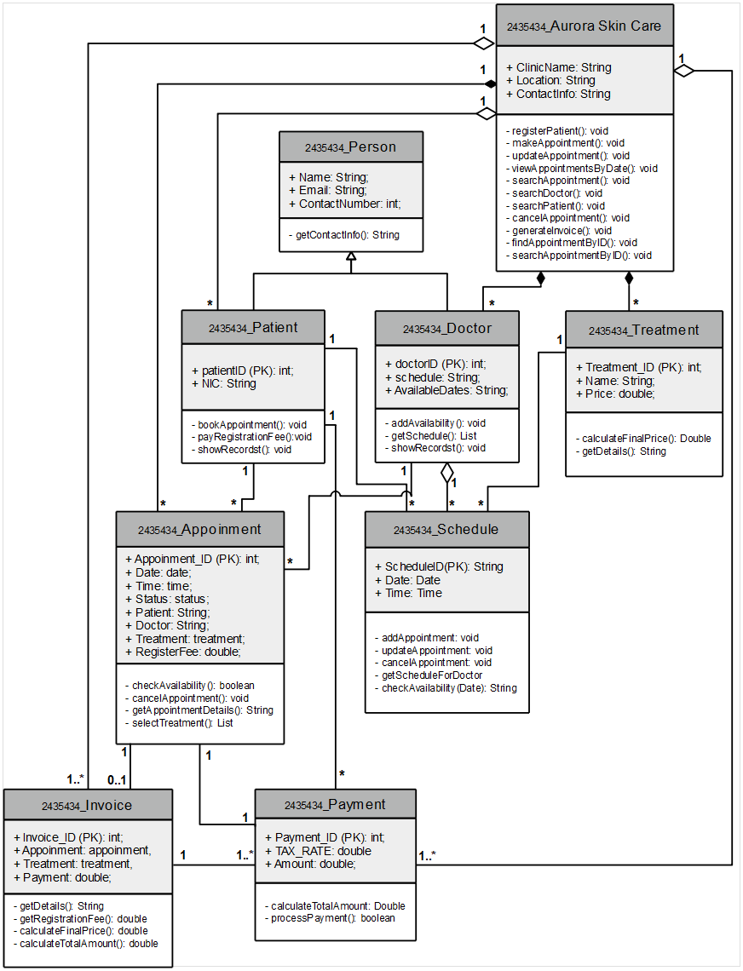

Figure 1 Class Diagram of Aurora Clinic Care System

### 2.1.1 How System Works Based on this UML Diagram

In the Aurora Skin Care system, the appointment and payment process are designed to provide a seamless experience for both patients and doctors. For example, suppose a patient named **Daenerys Stormborn** wants to schedule a skin treatment at Aurora Skin Care. Daenerys registers as a patient in the system, providing her contact information. She then checks the availability of her preferred doctor, **Dr. Ijlan (D001)**, by viewing Dr. Ijlan’s schedule in the system. After finding a suitable date, Daenerys uses the **bookAppointment** method to make an appointment with Dr. Ijlan for a treatment. This booking is managed by the Appointment class, which stores details such as the appointment date, time, doctor, and a registration fee.

On the scheduled date, Daenerys arrives at the clinic, and Dr. Ijlan performs her chosen treatment. Suppose she opted for **Skin Whitening**, priced at **7,650.00**. The treatment details, including the name and price, are recorded in the system under the Treatment class. After the treatment, the payment process begins. The system calculates the total fee, including any applicable taxes and additional charges, using the **calculateTotalAmount** method in the Payment class. Daenerys can then proceed to pay her bill, which the system processes using the **processPayment** method.

Invoice is generated, detailing the cost breakdown of Daenerys’s treatment, providing her with a clear record of services rendered. This workflow, supported by the Aurora Skin Care system, ensures efficient management of appointments, treatments, and payments, enhancing the overall experience for both patients and clinic staff.

### Class Overview

#### Aurora Skin Care

* **Purpose**: Represents the clinic itself, handling patient registration, appointment scheduling, doctor management, and invoice generation.
* **Methods**:
  + registerPatient(): Registers a new patient.
  + makeAppointment(): Creates a new appointment.
  + updateAppointment(): Modifies an existing appointment.
  + viewAppointmentsByDate(): Lists all appointments scheduled for a specific date.
  + searchAppointment(): Searches for appointments based on certain criteria.
  + searchPatient(): Searches for a specific patient in the system.
  + generateInvoice(): Creates an invoice for an appointment.
  + findAppointmentByID(): Finds an appointment using a unique ID.
  + searchAppointmentByID(): Searches for an appointment using its ID.
* **Relationships**:
  + **Aurora Skin Care → Patient**: One-to-many association, as the clinic can have multiple patients.
  + **Aurora Skin Care → Doctor**: One-to-many association, allowing the clinic to manage multiple doctors.
  + **Aurora Skin Care → Appointment**: One-to-many association, enabling the clinic to manage multiple appointments.
  + **Aurora Skin Care → Treatment**: One-to-many association, representing the various treatments available at the clinic.
  + **Aurora Skin Care → Invoice**: One-to-many association, allowing the clinic to generate invoices for each appointment or treatment.
* **Design Decision**: The choice to centralize operations like registration, appointment handling, and invoice generation within this class makes it an essential controller, enabling smooth management of all high-level actions.
* **Rationale**: This design simplifies the system's core functionalities by placing them in one class, which facilitates efficient data handling and processing across all entities.

#### Person

* **Purpose**: Serves as a base class for individuals in the system, including patients and doctors, containing common information.
* **Methods**:
  + getContactInfo(): Returns the contact details of the person.
* **Relationships**:
  + **Person → Patient**: Inheritance, as Patient is a specialized form of Person.
  + **Person → Doctor**: Inheritance, as Doctor is a specialized form of Person.
* **Design Decision**: By abstracting common attributes and methods in this superclass, such as getContactInfo(), the system reduces redundancy and improves reusability.
* **Rationale**: This design decision aligns with principles of object-oriented design by promoting inheritance and maintaining cleaner, more maintainable code.

#### Patient

* **Purpose**: Represents a patient, storing their unique identifiers and managing their interactions with the clinic.
* **Methods**:
  + bookAppointment(): Allows the patient to book an appointment.
  + payRegistrationFee(): Processes the patient's registration fee.
  + showRecords(): Displays the patient’s medical records or appointment history.
* **Relationships**:
  + **Patient → Appointment**: One-to-many association, as a patient can book multiple appointments.
  + **Patient → Aurora Skin Care**: Managed through the clinic's relationship, as Aurora Skin Care oversees all patient activities.
* **Design Decision**: The inclusion of these methods supports patient-specific actions, while inheriting basic details from **Person**.
* **Rationale**: Separating patient functionality into its own class makes it easier to manage patient interactions without complicating the **Person** class.

#### Doctor

* **Purpose**: Represents a doctor, storing their unique identifiers and schedule.
* **Methods**:
  + addAvailability(): Adds availability slots for the doctor.
  + getSchedule(): Retrieves the doctor’s schedule.
  + showRecords(): Displays the doctor’s records or availability.
* **Relationships**:
  + **Doctor → Appointment**: One-to-many association, as a doctor can have multiple appointments.
* **Design Decision**: By giving doctors control over their availability and allowing patient consultation through the **Schedule** class.
* **Rationale**: Doctors require unique functionalities that differ from patients, so it’s practical to maintain them as a separate class while allowing interaction through the shared **Schedule** class.

#### Schedule

* **Purpose**: Manages scheduling details, including dates and times, primarily for appointments and doctor availability.
* **Methods**:
  + addAppointment(): Adds an appointment to the schedule.
  + updateAppointment(): Updates details of a scheduled appointment.
  + checkAvailability(Date): Checks if a specific date is available.
* **Relationships**:
  + **Schedule → Doctor**: Many-to-one association, allowing each doctor to have multiple schedules.
* **Design Decision**: The separation of scheduling functionality from **Doctor** enables a more modular approach, allowing scheduling logic to be handled independently.
* **Rationale**: Keeping scheduling in a separate class allows for flexible date and time management, supporting potential future expansions like allowing multiple doctors with different schedules.

#### Appointment

* **Purpose**: Manages appointment details, including the date, time, patient, doctor, and treatment.
* **Methods**:
  + checkAvailability(): Checks if the appointment slot is available.
  + cancelAppointment(): Cancels the appointment.
  + getAppointmentDetails(): Provides details of the appointment.
  + selectTreatment(): Allows selection of a treatment for the appointment.
* **Relationships**:
  + **Appointment → Patient**: Many-to-one association, as each appointment is linked to one patient.
  + **Appointment → Doctor**: Many-to-one association, as each appointment is linked to one doctor.
  + **Appointment → Treatment**: One-to-one association, as each appointment involves a specific treatment.
  + **Appointment → Schedule**: One-to-one association, linking each appointment with a specific schedule.
* **Design Decision**: Placing all appointment-related details in one class allows for centralized tracking and management of appointments.
* **Rationale**: This class is crucial for maintaining the scheduling system, enabling easy retrieval, modification, and cancellation of appointments, thereby streamlining workflow.

#### Treatment

* **Purpose**: Represents different treatments offered at the clinic, including cost details.
* **Methods**:
  + calculateFinalPrice(): Calculates the final price for the treatment.
  + getDetails(): Returns details about the treatment.
* **Relationships**:
  + **Treatment → Appointment**: One-to-one association, as each appointment may involve a single treatment.
* **Design Decision**: By consolidating treatment details in one class, the system can easily manage and retrieve treatment information.
* **Rationale**: Centralizing treatments ensures consistency, especially for price calculations and retrieving detailed information, helping maintain accuracy in billing.

#### Payment

* **Purpose**: Manages financial transactions related to appointments and treatments.
* **Methods**:
  + calculateTotalAmount(): Calculates the total amount owed for services.
  + roundOffAmount(): Rounds the total amount to ensure accurate billing.
  + processPayment(): Processes the payment and validates its success or failure.
* **Relationships**:
  + **Payment → Appointment**: One-to-zero-or-one association, as each payment may be linked to a specific appointment.
  + **Payment → Invoice**: One-to-one association, as each payment is associated with a specific invoice.
* **Design Decision**: Placing all payment-related operations in one class allows the system to handle transaction processing in a centralized and standardized way.
* **Rationale**: Isolating payment functionality makes it easier to adjust payment processing rules and ensures consistency in transaction handling.

#### Invoice

* **Purpose**: Represents billing details for appointments and treatments, including registration fees and total charges.
* **Methods**:
  + getDetails(): Returns details of the invoice.
  + getRegistrationFee(): Retrieves the registration fee amount.
  + calculateFinalPrice(): Calculates the final price of the treatment or appointment.
  + calculateTotalAmount(): Calculates the total amount due on the invoice.
* **Relationships**:
  + **Invoice → Appointment**: One-to-one association, as each invoice corresponds to a specific appointment.
  + **Invoice → Treatment**: One-to-one association, as each invoice includes the treatment cost.
  + **Invoice → Payment**: One-to-one association, linking each invoice to a specific payment.
* **Design Decision**: Separating invoices from **Payment** supports modularity, allowing the **Invoice** class to handle detailed billing and calculation of the final payable amount independently.
* **Rationale**: This design decision aligns with good practices by decoupling financial calculations and payment processing, making the system more adaptable and manageable.

## System Design

### Main Menu of the Aurora Skin Care System

the Aurora Skin Care Clinic system offers a convenient and efficient way to manage their appointments and interact with the clinic. The menu provides easy access to essential functions like booking appointments, updating information, viewing appointment details, and searching for specific information. This system can save users time and effort by eliminating the need for phone calls or in-person visits for routine tasks.

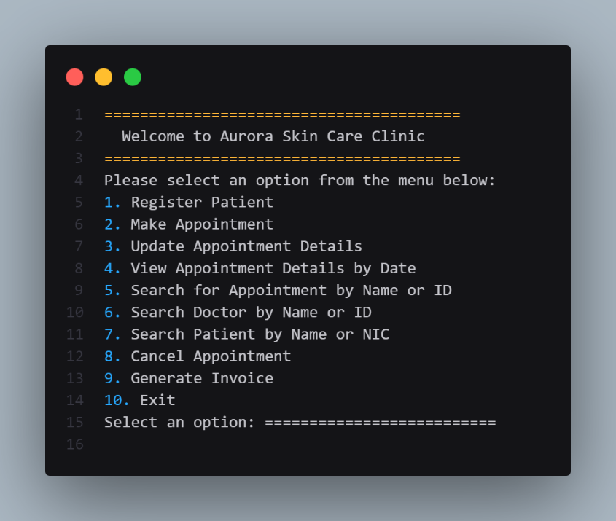

Figure 2 CLI Snap 01 - Main Menu of the system

### Patient Registration

The user selects the "Register New Patient" option from the menu and is then prompted to enter the patient's name, email address, contact number, and NIC (National Identity Card) number. Once the information is entered, the system displays a message confirming that the patient has been registered successfully.

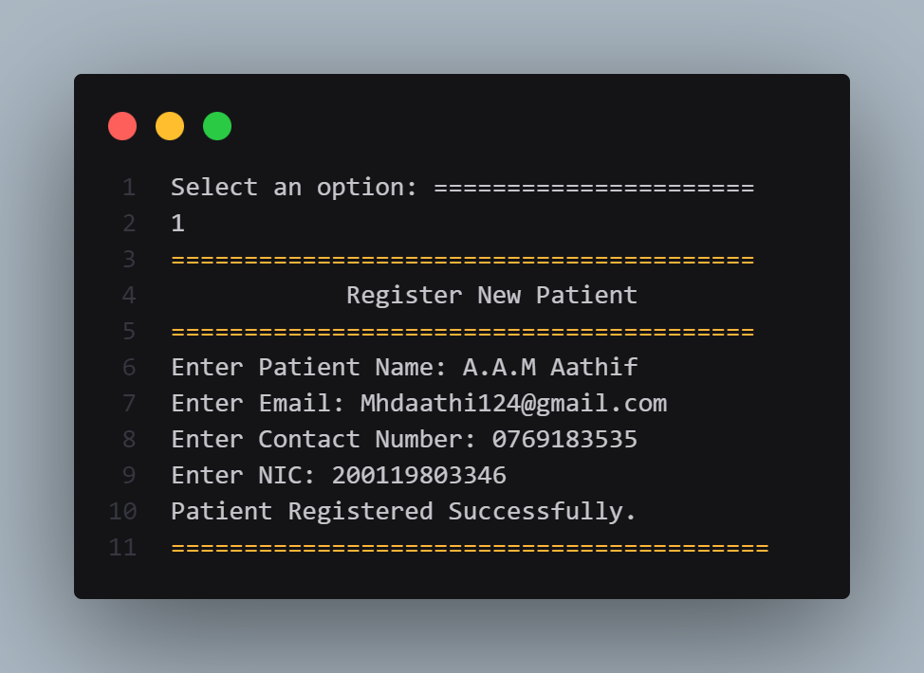

Figure 3 CLI Snap 02 - Patient Registration

### Make Appointment

The appointment booking process appears to be straightforward and user-friendly. The clear prompts guide the user through the necessary steps, making it easy to input the required information. The confirmation message provides immediate feedback, assuring the user that the appointment was booked successfully. The system also provides a clear summary of the appointment details, including the appointment ID, date, time, doctor, treatment type, and price.

The user selects the "Make a New Appointment" option from the menu and is then prompted to enter the patient's NIC (National Identity Card) number, desired date and time, and choose a doctor and treatment type from the available options. Once the information is entered, the system displays a message confirming that the appointment has been booked successfully. In this specific case, the user A.A.M Aathif booked an appointment with Dr. Brian for Skin Whitening treatment, which costs LKR 7650.00.

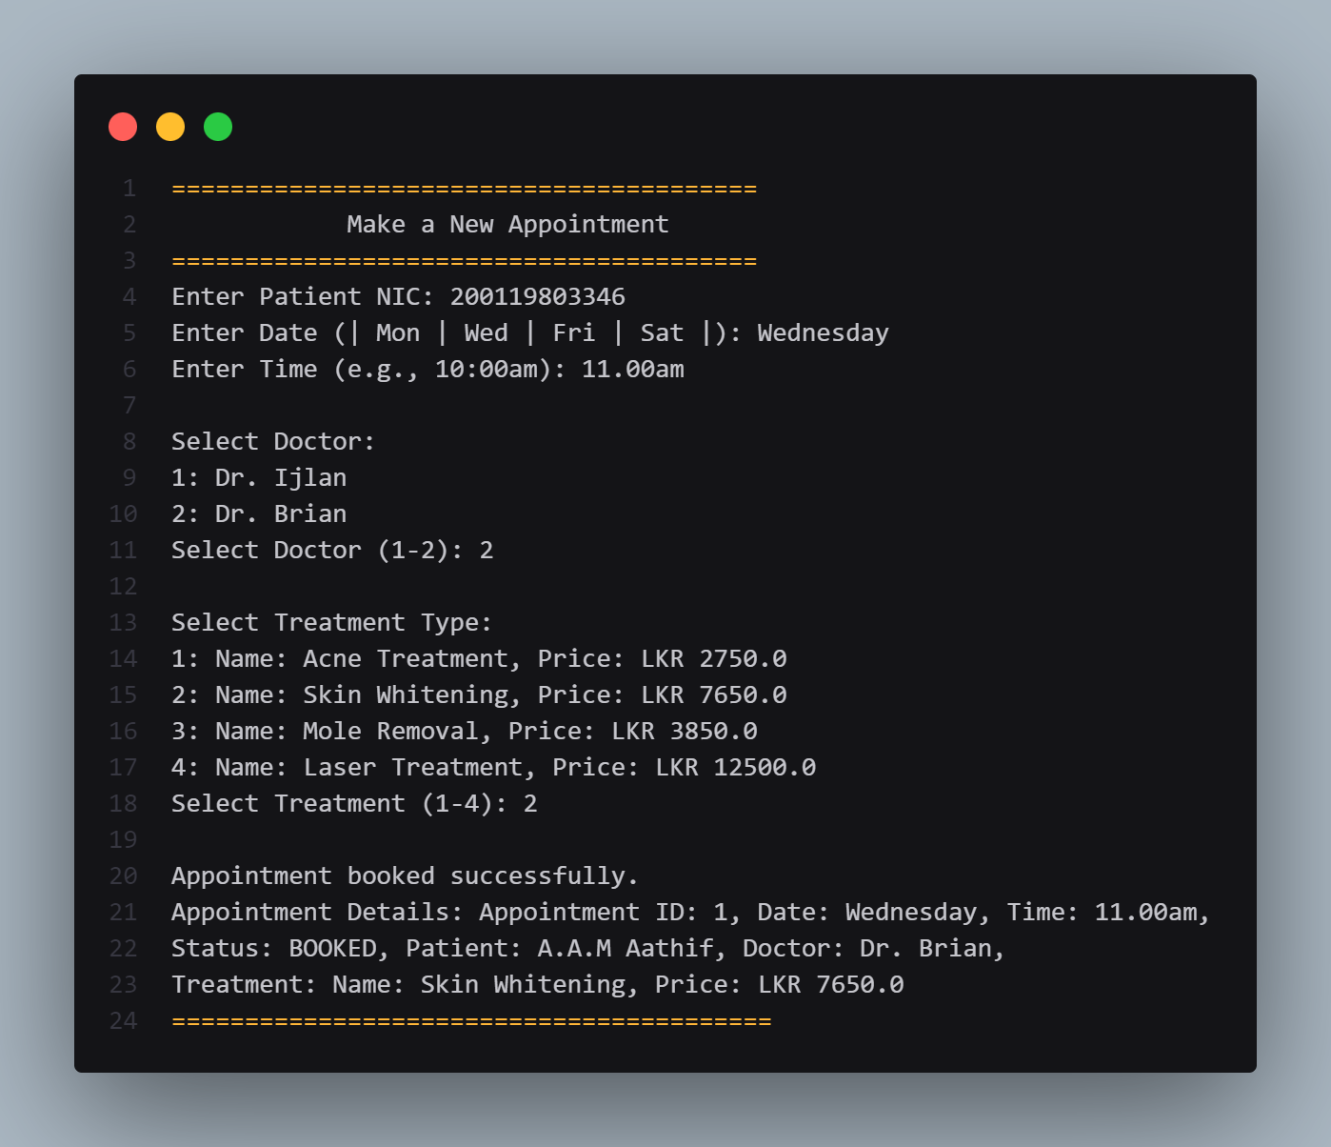

Figure 4 CLI Snap 03 - Make Appointment

### Update Appointment by Date, Time

The user selects the "Update Appointment Details" option from the menu and is then prompted to enter the appointment ID to be updated, the New Date, and the New Time. Once the information is entered, the system displays a message confirming that the appointment has been updated successfully. In this specific case, the user successfully changed the appointment date from Monday to Saturday and the time from 11:00 AM to 1:00 PM.

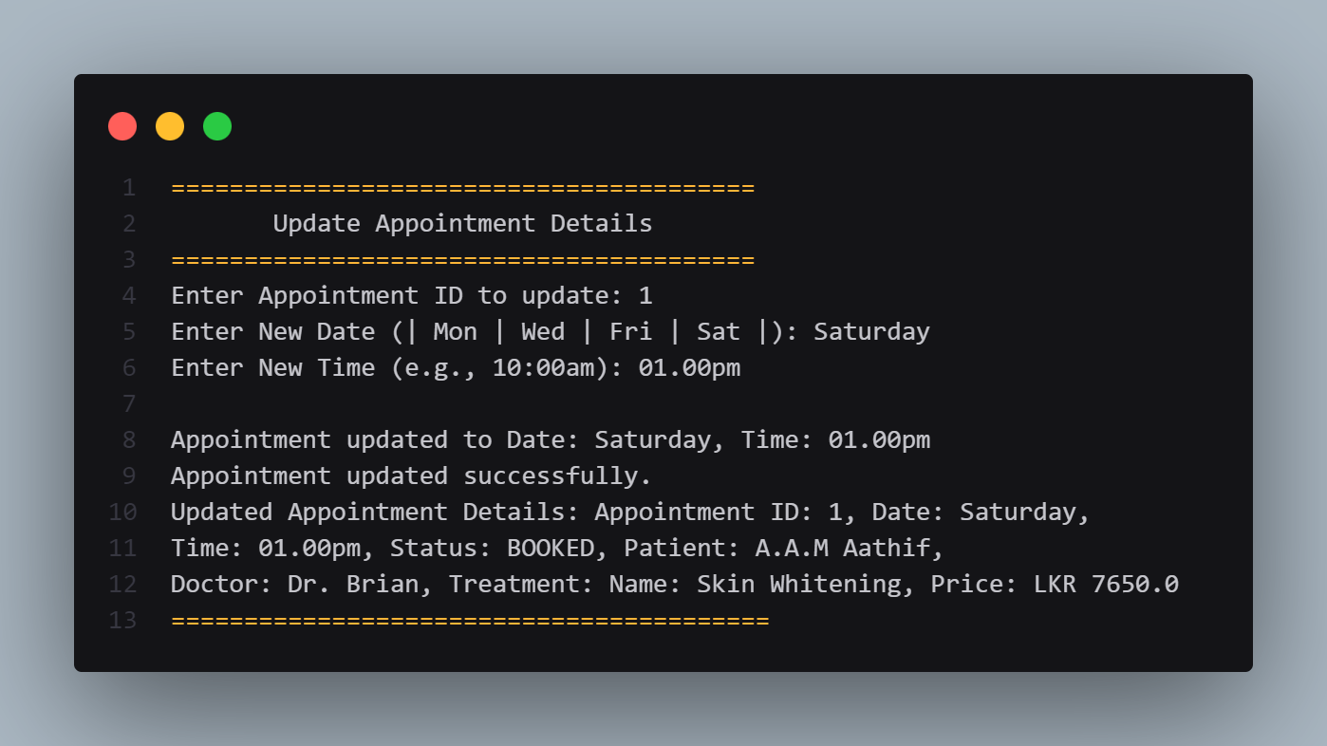

Figure 5 CLI Snap 04 - Update Appointment by Date, Time

### View Appointment by Date

The user selects the "View Appointments by Date" option from the menu and is then prompted to enter the desired date to filter the appointments. Once the date is entered, the system displays a list of appointments scheduled for that date. In this specific case, the user entered "Saturday" and the system displayed the details of an appointment with ID 1, scheduled for Saturday at 1:00 PM with Dr. Brian for Skin Whitening treatment, which costs LKR 7650.0.

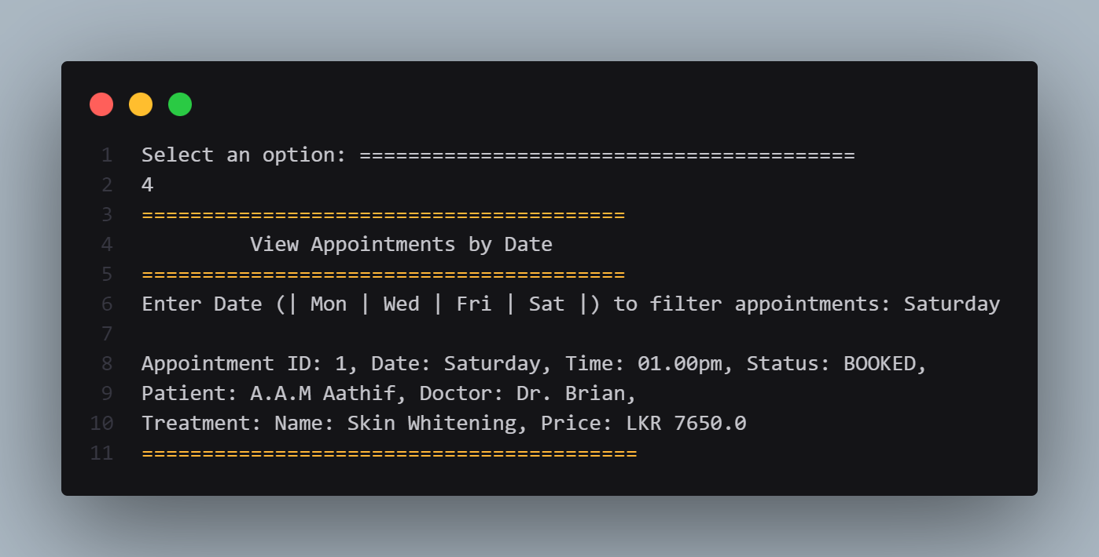

Figure 6 CLI Snap 05 - View Appointment by Date

### Search Appointment by Patient Name / Appointment ID

#### Search by Appointment ID

The user selects the "Search Appointment by Patient Name / Appointment ID" option from the menu and is then prompted to enter either the appointment ID or the patient name to search for the appointment details. In this specific case, the **user entered "1" as the appointment ID** and the system displayed the details of the appointment with ID 1, scheduled for Saturday at 1:00 PM with Dr. Brian for Skin Whitening treatment, which costs LKR 7650.0.

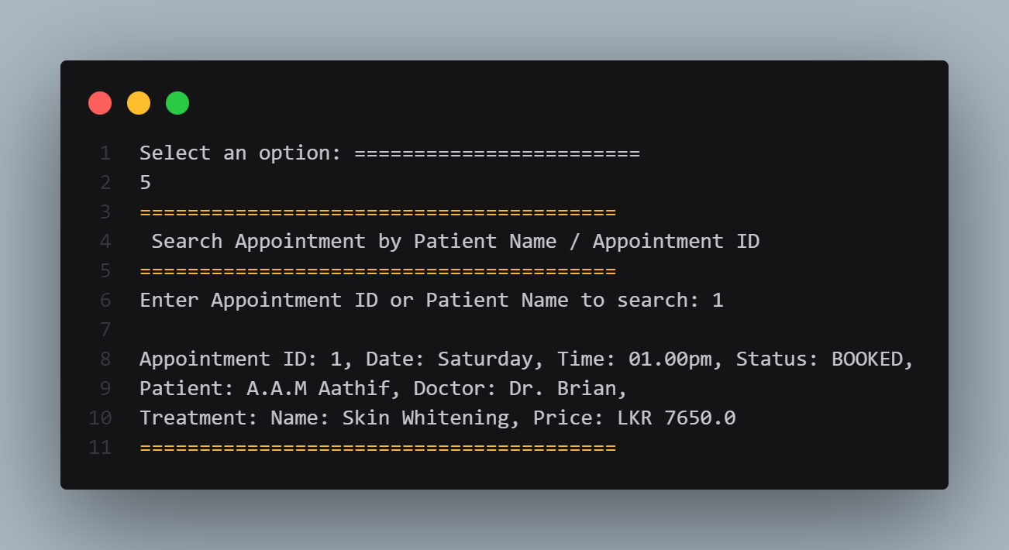

Figure 7 CLI Snap 06 - Search Appointment by Appointment ID

#### Search by Patient Name

The user selects the "Search Appointment by Patient Name / Appointment ID" option from the menu and is then prompted to enter either the appointment ID or the patient name to search for the appointment details. In this specific case, the **user entered "A.A.M Aathif" as the patient name** and the system displayed the details of the appointment with ID 1, scheduled for Saturday at 1:00 PM with Dr. Brian for Skin Whitening treatment, which costs LKR 7650.0.

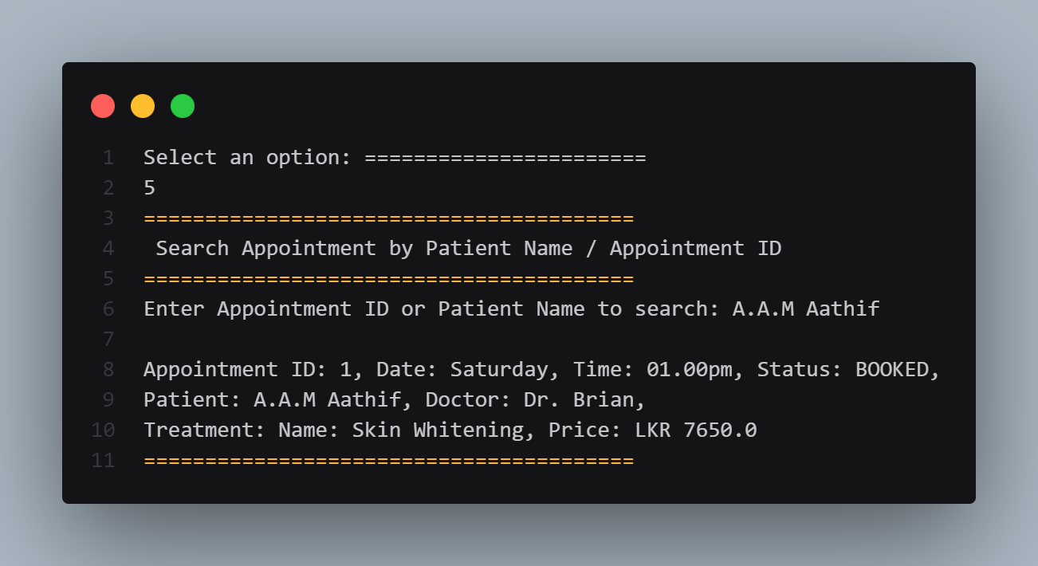

Figure 8 CLI Snap 07 - Search Appointment by Patient Name

### Search Doctor

#### Search by Doctor ID

The user selects the "Search for a Doctor" option from the menu and is then prompted to enter either the doctor's name or ID to search for the doctor's details. In this specific case, the user entered "D001" as the doctor's ID and the system displayed the details of the doctor with Employee ID D001, name Dr. Ijlan, email mohamedijlan02@gmail.com, and contact number 0776778795.

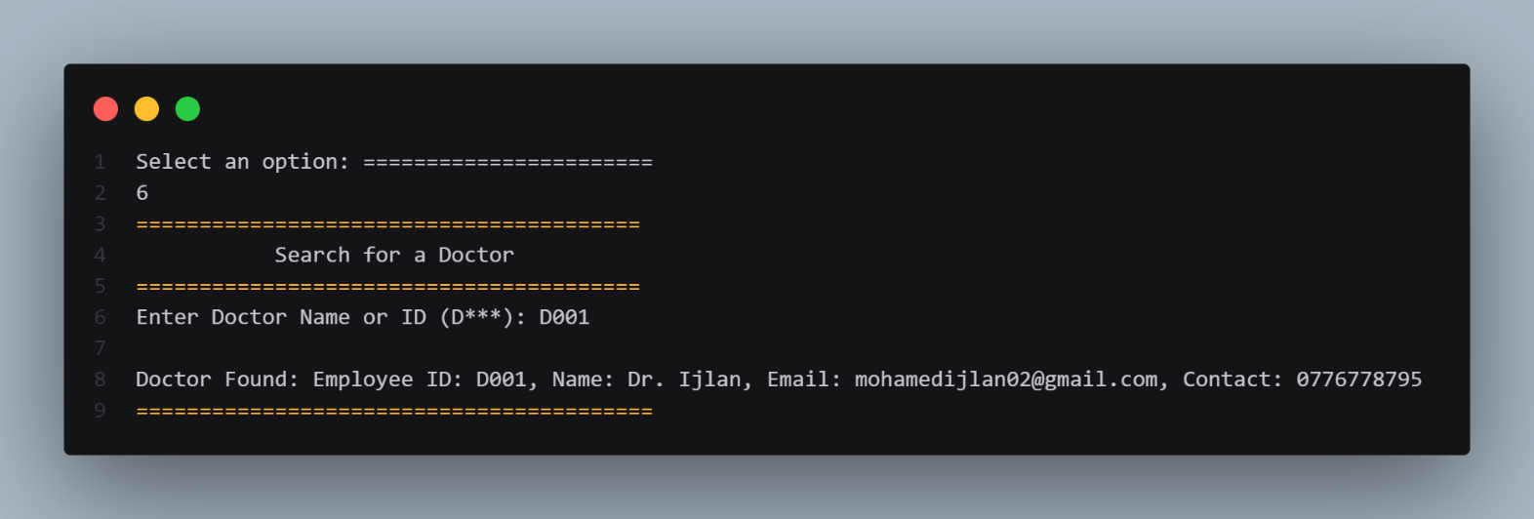

Figure 9 CLI Snap 08 - Search Doctor by Doctor ID

#### Search by Doctor Name

The user selects the "Search for a Doctor" option from the menu and is then prompted to enter either the doctor's name or ID to search for the doctor's details. In this specific case, the user entered "Dr. Brian" as the doctor's name and the system displayed the details of the doctor with Employee ID D002, name Dr. Brian, email jacobmichaelbrian01@gmail.com, and contact number 0764517561.

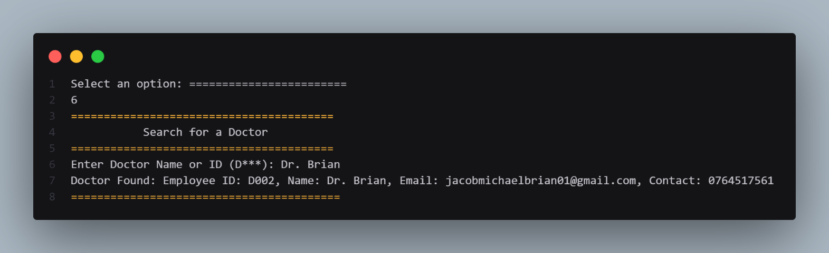

Figure 10 CLI Snap 09 - Search Doctor by Doctor Name

### Search Patient by Name / NIC

#### Search by NIC

The user selects the "Search for a Patient" option from the menu and is then prompted to enter either the patient's name or NIC (National Identity Card) number to search for the patient's details. In this specific case, the user entered "200119803346" as the NIC number and the system displayed the details of the patient with name A.A.M Aathif, email Mhdaathi124@gmail.com, contact number 0769183535, and NIC 200119803346.

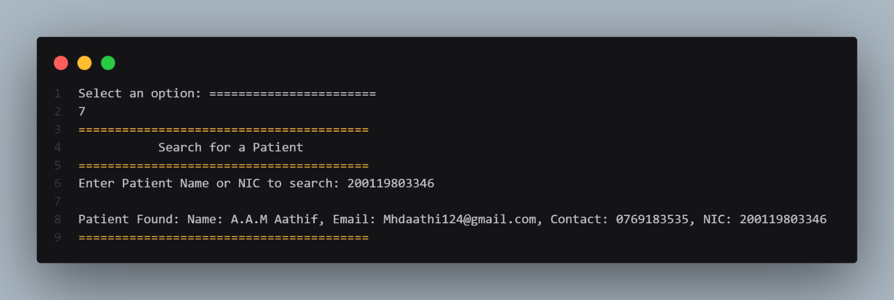

Figure 11 CLI Snap 10 - Search Patient by NIC

#### Search by Patient Name

The user selects the "Search for a Patient" option from the menu and is then prompted to enter either the patient's name or NIC (National Identity Card) number to search for the patient's details. In this specific case, the user entered "A.A.M Arshak" as the patient name and the system displayed the details of the patient with name A.A.M Arshak, email Mohamedarshak48@gmail.com, contact number 0778211464, and NIC 200335600465.

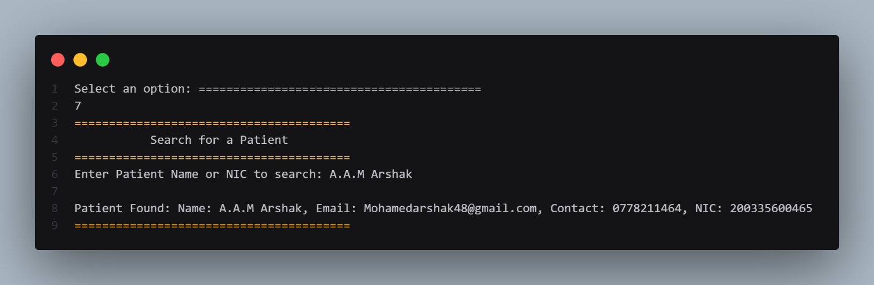

Figure 12 CLI Snap 11 - Search Patient by Patient Name

### Cancel Appointment

The user selects the "Cancel Appointment" option from the menu and is then prompted to enter the appointment ID to be canceled. In this specific case, the user entered "1" as the appointment ID and the system displayed a message confirming that the appointment with ID 1 has been canceled. This indicates that the appointment for A.A.M Aathif has been successfully canceled.

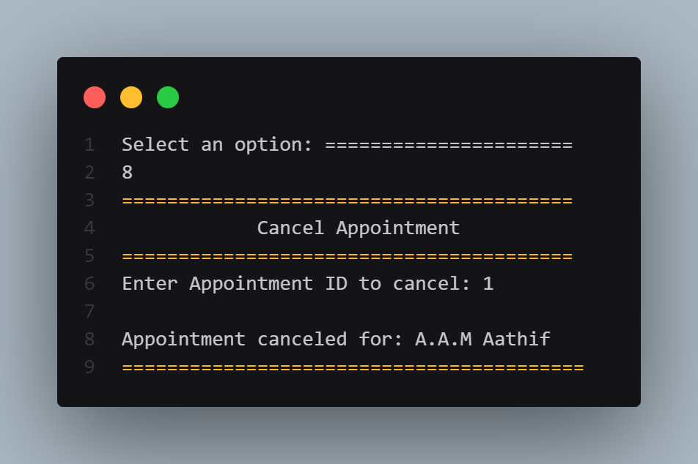

Figure 13 CLI Snap 12 - Cancel Appointment

### Generate Invoice

The user selects the "Generate Invoice" option from the menu and is then prompted to enter the appointment ID and select the treatment type. In this specific case, the user entered "1" as the appointment ID and selected "2" for Skin Whitening treatment. The system will then generate an invoice for the specified appointment and treatment.

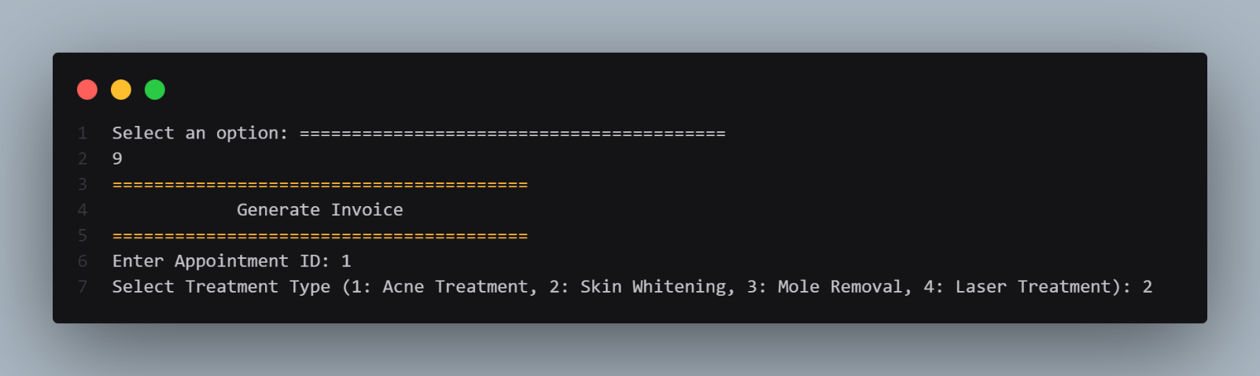

Figure 14 CLI Snap 13 - Generate Invoice

### Invoice

The invoice shows the details of the appointment made by A.A.M Aathif on Saturday at 1:00 PM for Skin Whitening treatment. The total cost of the appointment, including the treatment fee, registration fee, and tax.

* **Tax (2.5%):** LKR 191.25 (Calculated as 2.5% of the total amount: (7650 + 500) * 0.025)
* **Total:** LKR 7841.25

(Calculated as the sum of treatment fee, registration fee, and tax: 7650 + 500 + 191.25)

The invoice also includes a thank you message from the clinic.

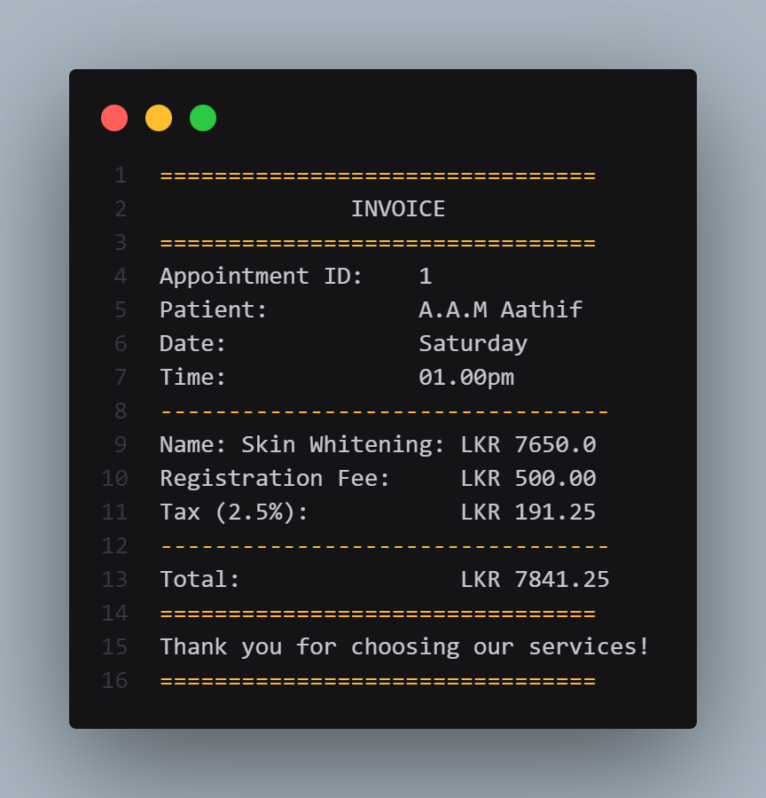

Figure 15 CLI Snap 14 - Invoice

### Exit

The user selects the "Exit" option from the menu, indicated by entering "10". The system then displays a farewell message, "Exiting the system. Goodbye!", confirming the user's exit from the system.

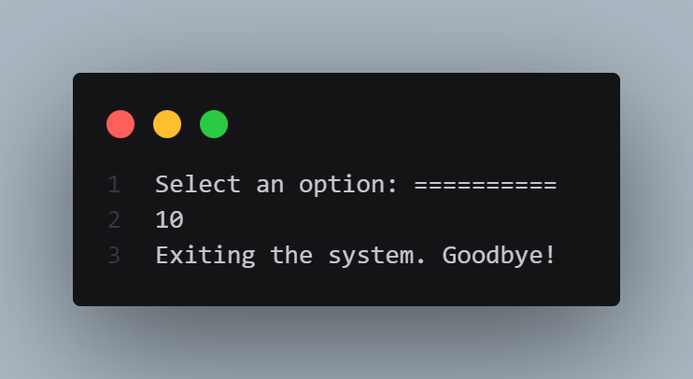

Figure 16 CLI Snap 15 - Exit

# Activity 03 – Implementation

## The Implementation of the Aurora Skin Care

### Main Program Class

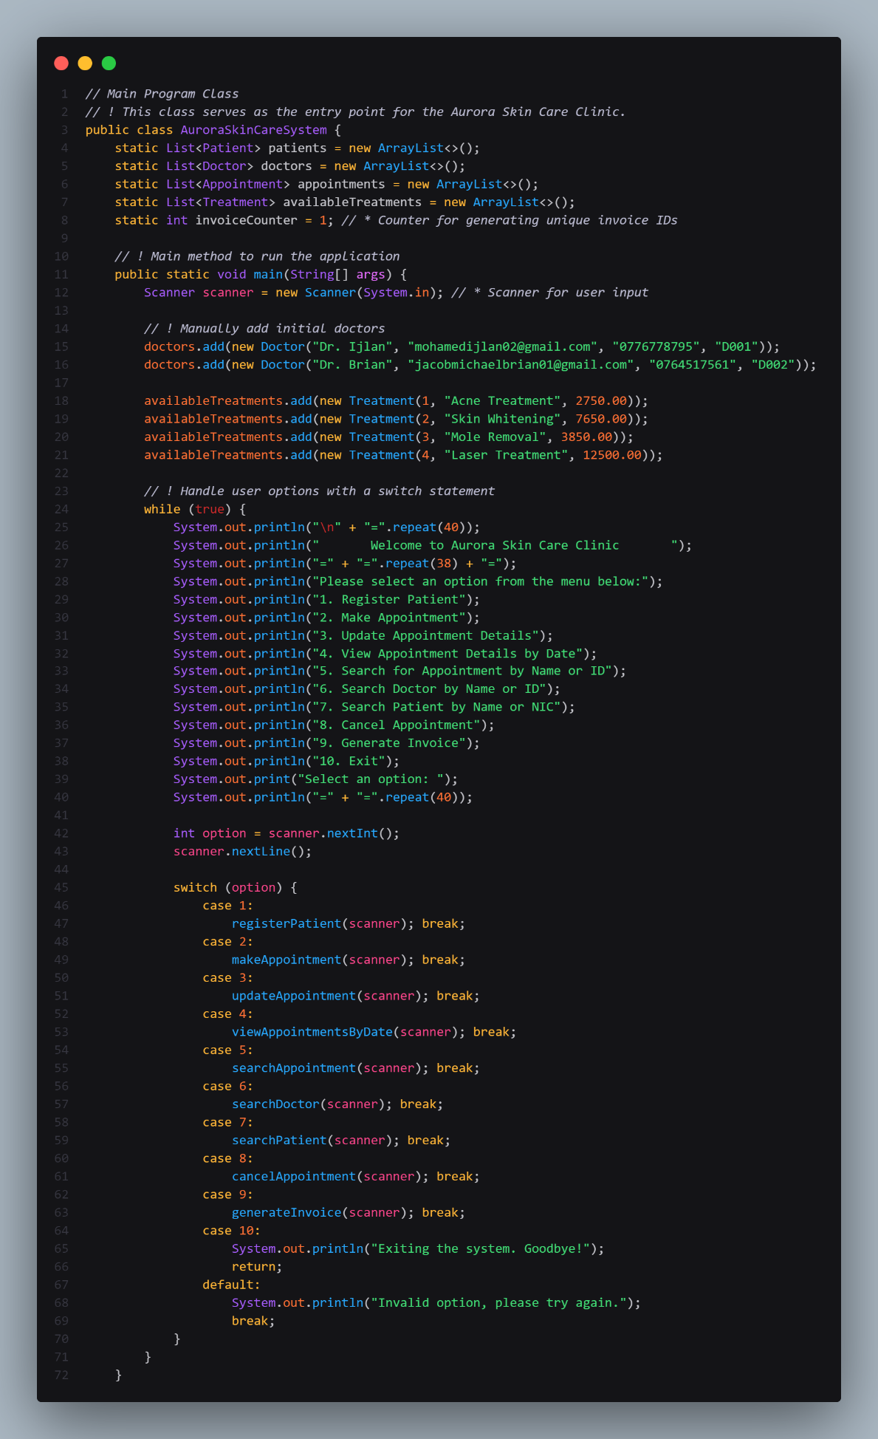

Figure 17 Code Snippet 01 - Main Program Class

### Person Class

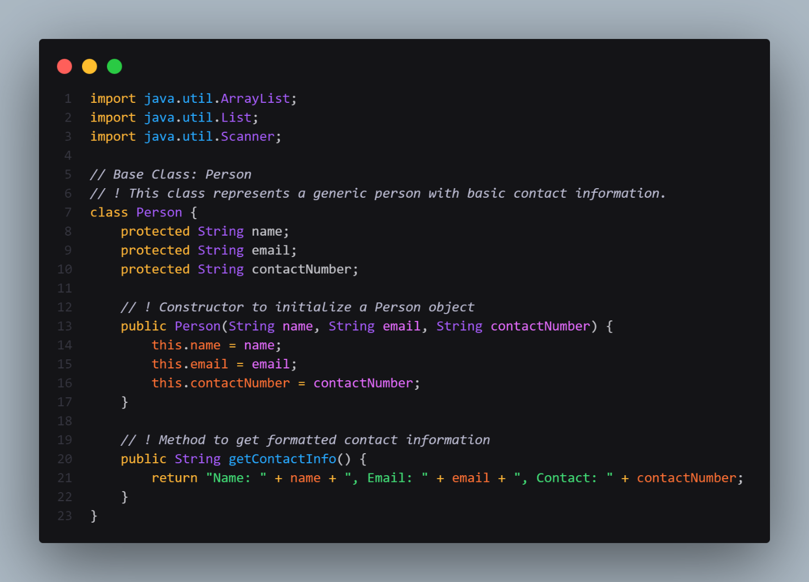

Figure 18 Code Snippet 02 - Person Class

The Person class in Java provides a structured way to represent individuals with basic contact details, including name, email, and contact number. When a Person object is created, its constructor is called with these details, which are stored in the object's fields. This information is encapsulated, meaning it can only be accessed through specific methods, ensuring data security and consistency.

The getContactInfo() method formats and returns a string combining the person's name, email, and contact number, making it easy to display or use the information elsewhere in the application. This class enables efficient management of contact information for multiple individuals within a program.

### Patient Class

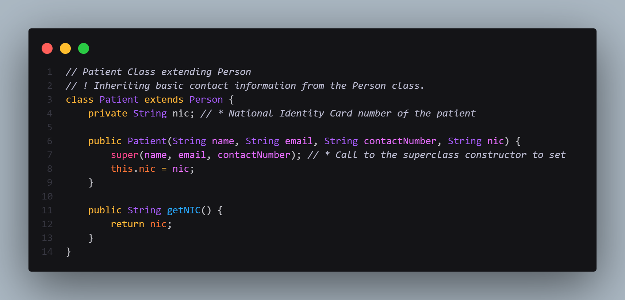

Figure 19 Code Snippet 03 - Patient Class

The Patient class in Java extends the Person class, inheriting its basic contact information fields name, email, and contact number. It adds a specific field, nic, to store the patient's National Identity Card number. Through inheritance, Patient objects have access to the fields and methods of Person, including getContactInfo(), making it easy to reuse code.

The Patient constructor accepts the name, email, contact number, and NIC as arguments, using the Person constructor to initialize the inherited fields and setting nic for the specific patient. The getNIC() method provides access to the NIC value, making it easy to retrieve. This class showcases inheritance in object-oriented programming by building upon a general Person class to create a specialized Patient class with additional, relevant details.

#### Register Patient Method

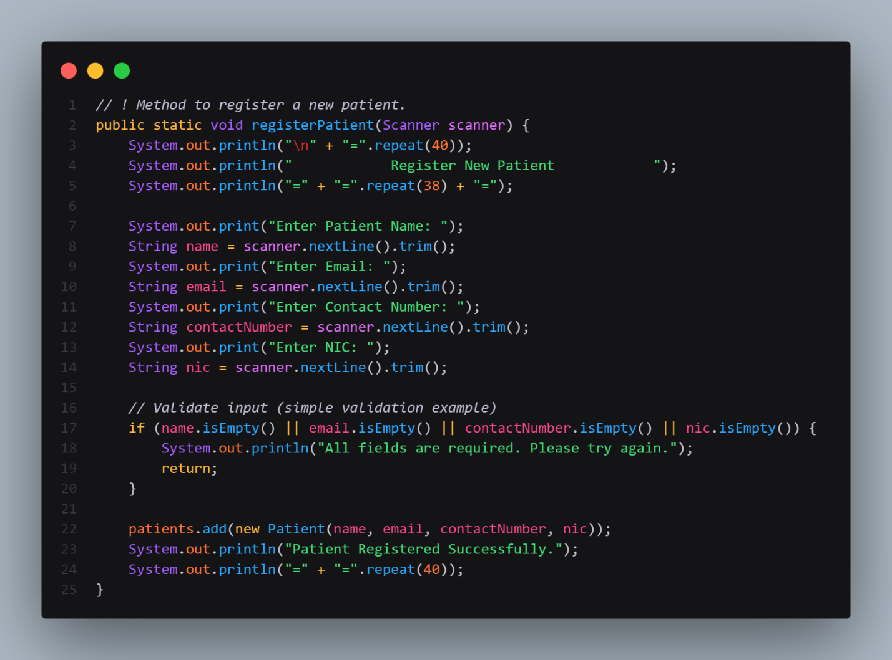

Figure 20 Code Snippet 04 - Register Patient Method

**Creating the Patient Object:**

* **New Patient Creation**: Once all input fields are successfully filled, a new Patient object is created using the provided details. The patient's name, email, contact number, and NIC are passed to the constructor of the Patient class to instantiate the object.

**Adding to the Patients List:**

* **Storing the Patient**: After the Patient object is created, it is added to the list of patients (patients list). This list stores all registered patients in the system, making it possible to manage and retrieve patient data later.

**Error Handling:**

* **Empty Fields Error**: If any of the required fields are left empty during input, the method displays an error message. This prevents incomplete data from being entered into the system and ensures that all required information is captured before the patient is registered.

#### Search Patient Method

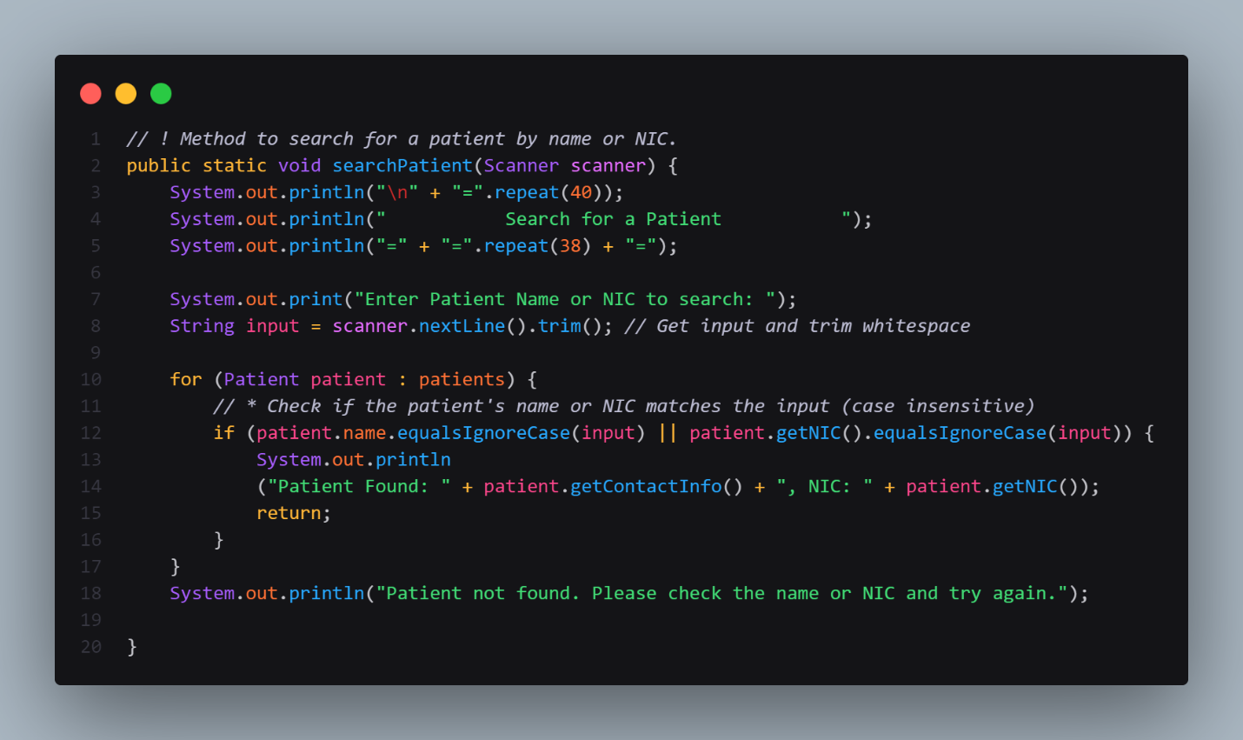

Figure 21 Code Snippet 05 - Search Patient Method

* **Input Handling**: The method ensures that the user provides a valid search term (name or NIC). It uses Scanner to capture this input and applies the trim() method to eliminate leading and trailing spaces, improving search accuracy.
* **Search Logic**: The method then loops through the list of patients stored in the system. For each patient, it compares the input string to both the patient's name and NIC in a case-insensitive manner using equalsIgnoreCase(). This makes the search more flexible and user-friendly, as it doesn't require the user to match the exact case of the letters in the name or NIC.
* **Output Handling**: If a match is found, the method prints the relevant contact information, including the patient's name, contact details, and NIC, to the console. This allows the user to quickly view the necessary details of the matched patient. If no patient is found that matches the search criteria, the method displays an error message.
* **Error Handling**: The method includes a simple error message to notify the user if no match is found, improving the user experience by providing feedback when the search is unsuccessful.

### Doctor Class

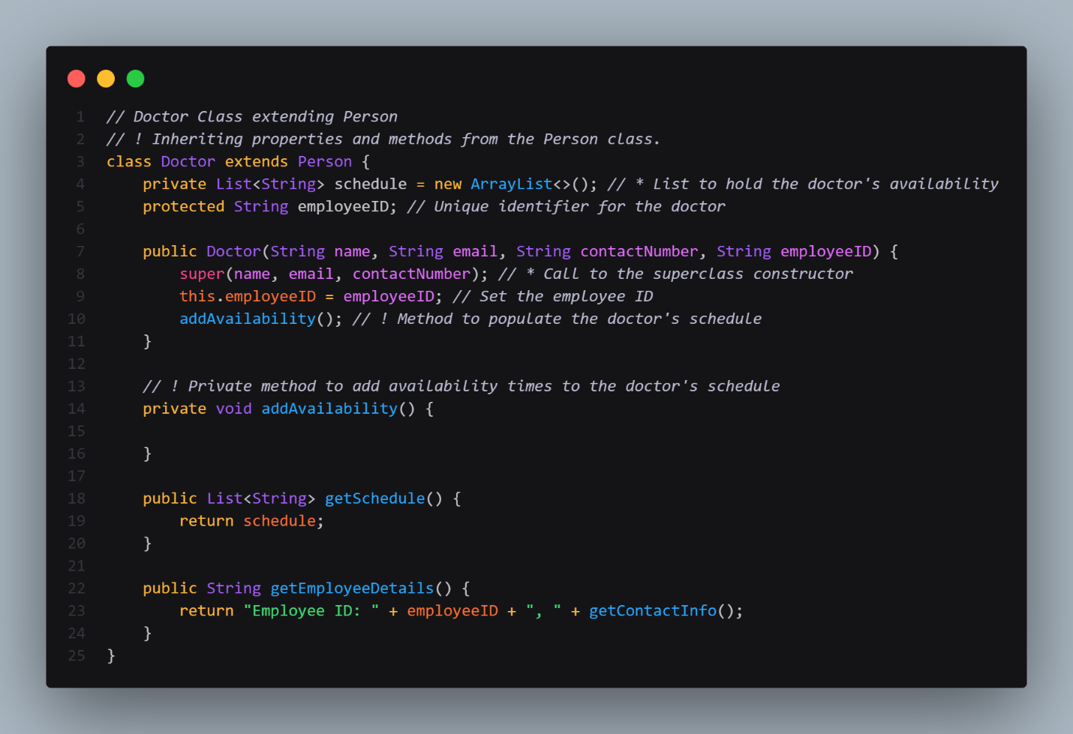

Figure 22 Code Snippet 06 - Doctor Class

The Doctor class extends the Person class, inheriting its basic contact information properties. It adds two additional fields:

* schedule: A List to store the doctor's availability slots.
* employeeID: A unique identifier for the doctor.

The Doctor class also has a constructor that initializes the inherited fields from the Person class and sets the employeeID field. It also calls a private method addAvailability() to populate the schedule list with the doctor's availability times.

The getSchedule() method returns the doctor's availability schedule, and the getEmployeeDetails() method returns a string containing the doctor's employee ID and contact information. The Doctor class builds upon the Person class to create a specialized representation of a doctor, including their availability and unique identifier.

#### Search Doctor Method

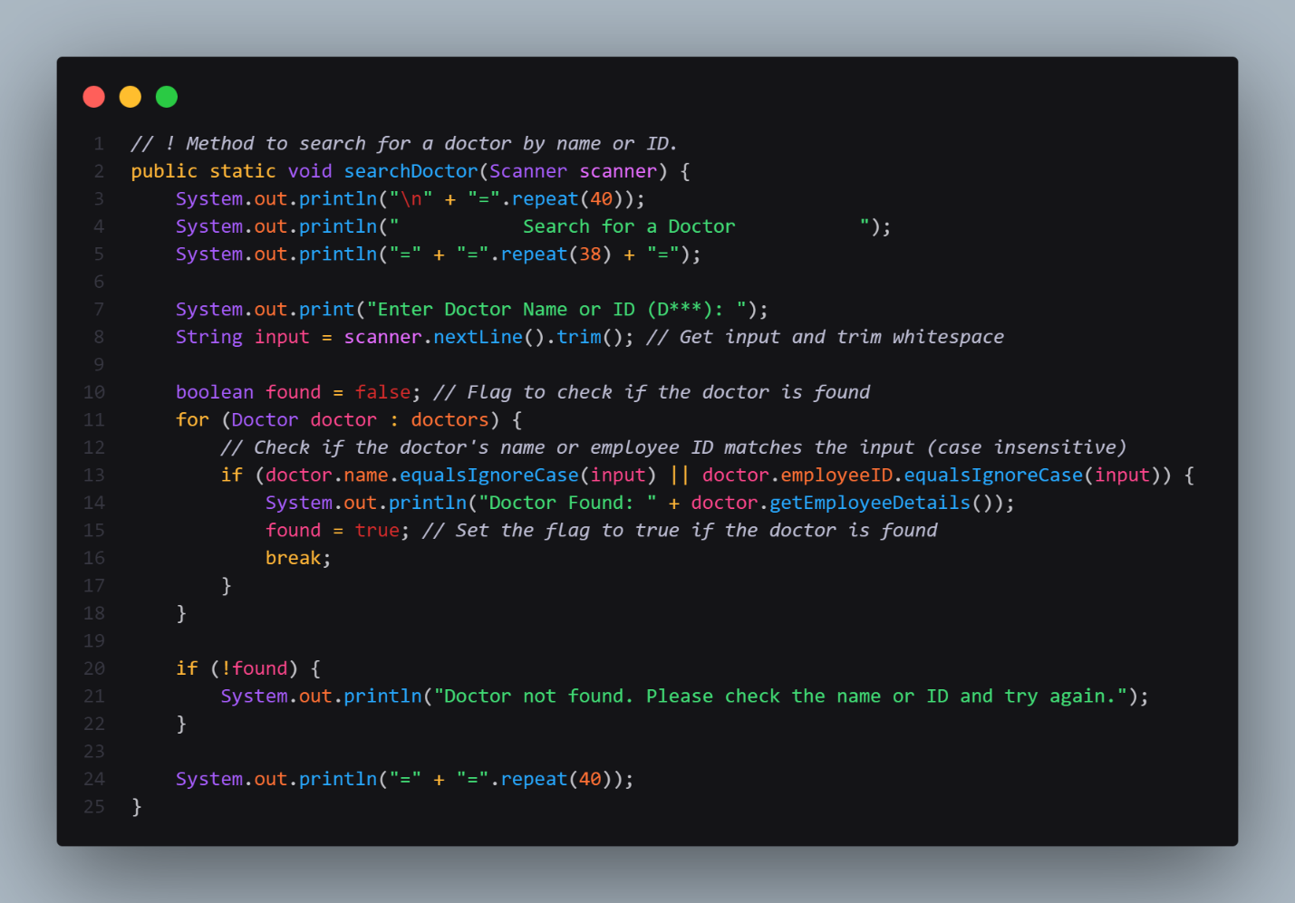

Figure 23 Code Snippet 07 - Search Doctor Method

* **Input Handling:** The method accepts a Scanner object as input, which is used to capture the search criteria (name or employee ID) from the user via the console. The method prompts the user to enter either the name or the employee ID of the doctor they wish to search for.
* The input is trimmed to remove any leading or trailing whitespace to ensure the search is clean and accurate.
* **Search Logic:** After receiving the input, the method iterates through the list of doctors stored in the system. For each doctor, it checks whether the input (name or employee ID) matches the corresponding fields of any doctor.
* The comparison is case-insensitive, ensuring that capitalization differences in the input do not affect the search results.

### Appointment Class

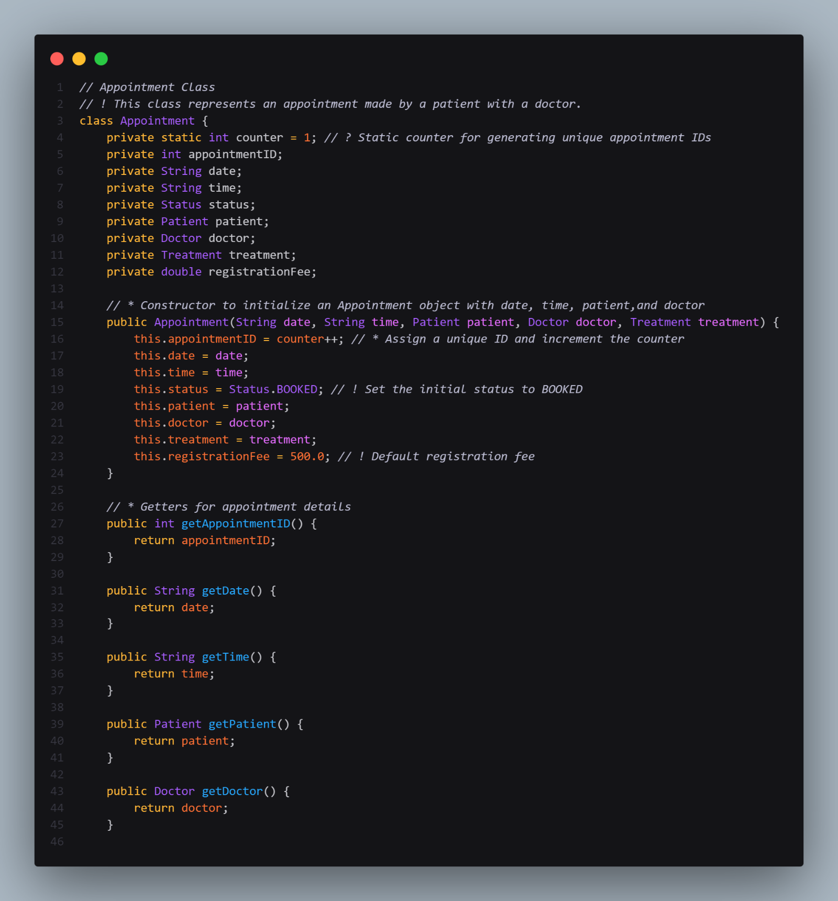

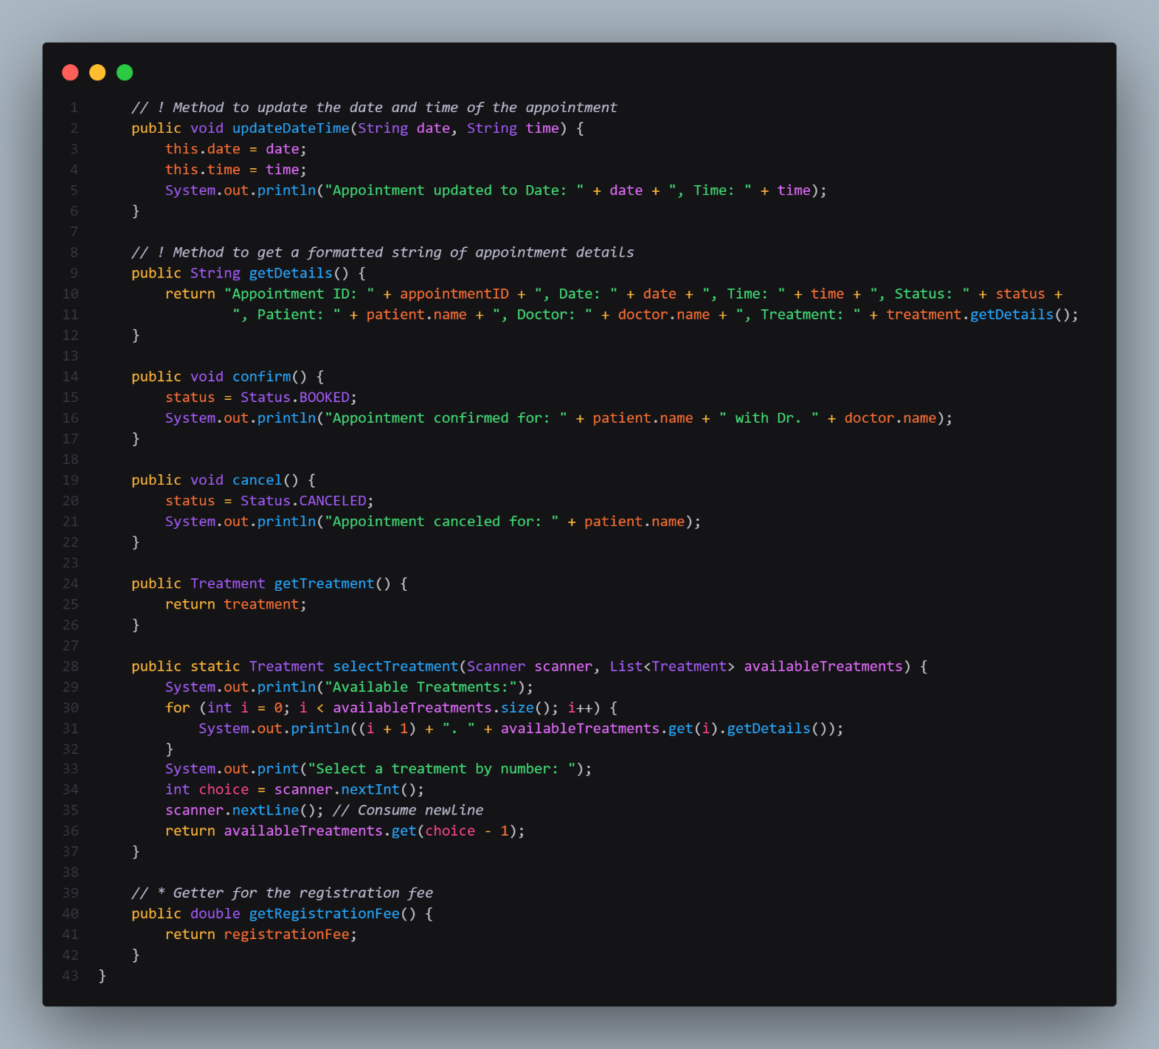

Figure 24 Code Snippet 08 - Appointment Class

The Appointment class models an appointment between a patient and a doctor within a healthcare system, including essential details like a unique appointmentID, date, time, status, associated patient and doctor, planned treatment, and registration fee. It provides a constructor to initialize these fields and getter methods to access each attribute. Key methods include updateDateTime() to modify the appointment's date and time, getDetails() to retrieve a formatted summary of appointment information, confirm() to mark the appointment as "BOOKED," and cancel() to mark it as "CANCELED." selectTreatment() allows users to choose from a list of treatments, while getTreatment() and getRegistrationFee() return the assigned treatment and fee. This class enables comprehensive management and tracking of patient appointments, providing functionality to confirm, cancel, and update appointments as needed.

#### Make New Appointment Method

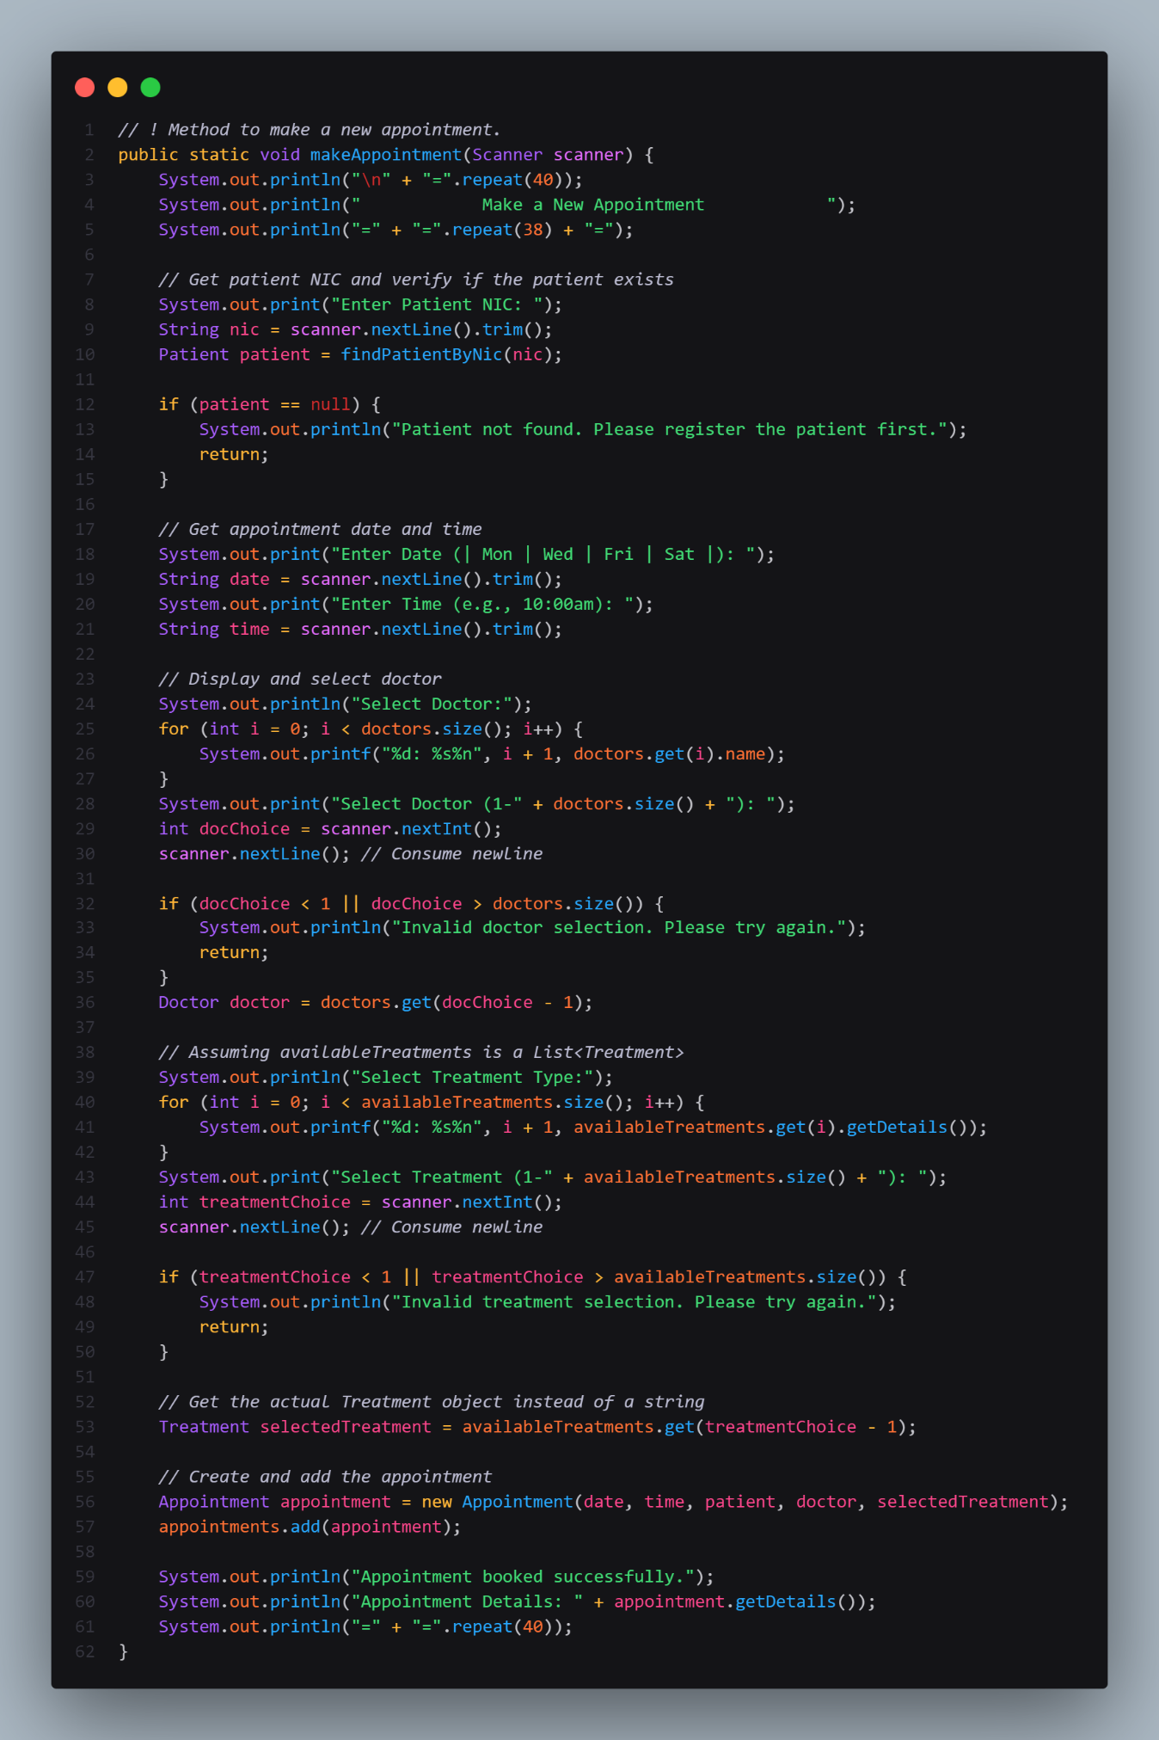

Figure 25 Code Snippet 09 - Make New Appointment Method

**Input Handling:**

* Prompts the user to enter required information (e.g., patient name, doctor ID, appointment details).
* Validates the input to ensure it meets specific criteria (e.g., non-empty strings, valid date formats).
* Trims any leading or trailing whitespace from the input.

**Object Creation:**

* Creates instances of classes (e.g., Patient, Doctor, Appointment) to represent real-world entities.
* Initializes the objects with appropriate values based on user input or other data sources.

**Search Logic:**

* Iterates through a list of objects (patients, doctors, appointments) to find a match.
* Compares the user's input with the relevant fields of each object (e.g., name, ID, date).
* Uses case-insensitive comparisons to improve search accuracy.

**List Addition:**

* Adds newly created objects to relevant lists (e.g., patients, doctors, appointments).
* Manages the list of objects to ensure efficient searching and retrieval.

**Error Handling:**

* Checks for invalid input (e.g., empty strings, invalid dates).
* Handles exceptions that may occur during input/output operations or data processing.
* Provides informative error messages to guide the user.

#### Update Existing Appointment Method

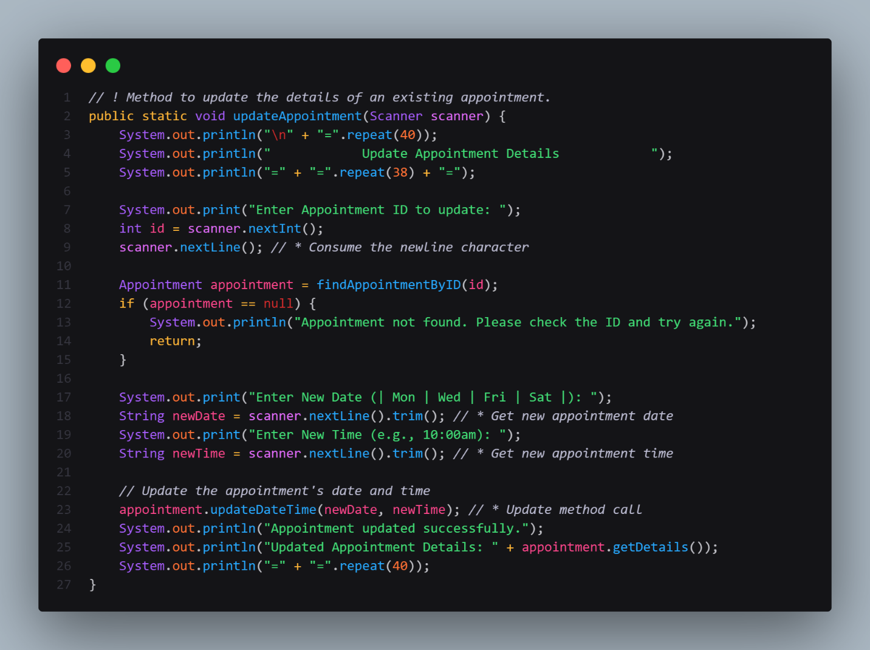

Figure 26 Code Snippet 10 - Update Existing Appointment Method

**Input Handling:**

* Prompts the user to enter the appointment ID to be updated.
* Validates the entered ID by searching for the corresponding appointment in the list.
* If the appointment is not found, an error message is displayed.
* Prompts the user to enter the new date and time for the appointment.

**Search Logic:**

* Uses the findAppointmentById method to locate the appointment with the specified ID.
* Iterates through the list of appointments to find a match based on the ID.

**Object Modification:**

* Calls the updateDateTime method of the Appointment object to modify its date and time fields.
* Updates the appointment's state within the list of appointments.

**Error Handling:**

* Checks if the appointment with the given ID exists.
* Provides an error message if the appointment is not found.

#### View Appointment Method

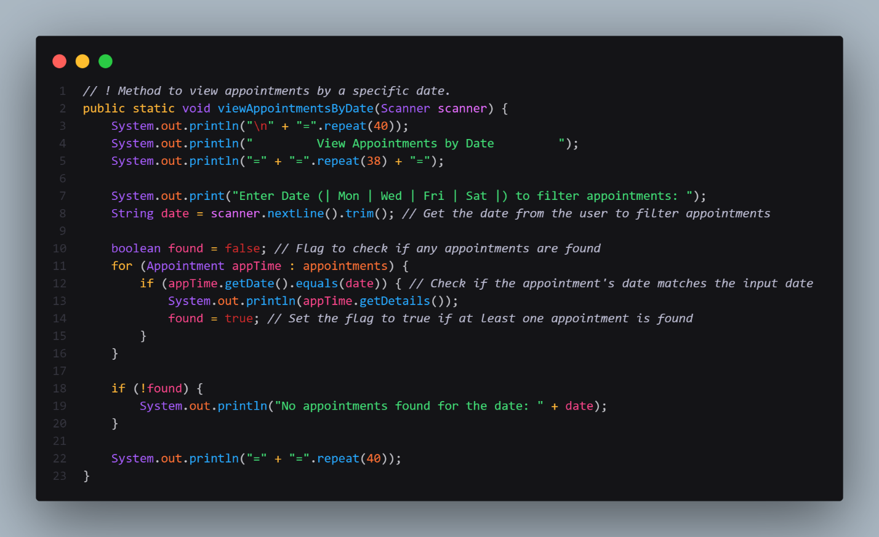

Figure 27 Code Snippet 11 - Update Existing Appointment Method

**Input Handling:**

* Prompts the user to enter a specific date (e.g., "Mon", "Wed", "Fri", "Sat") to filter appointments.
* Validates the input to ensure it matches one of the allowed date formats.

**Search Logic:**

* Iterates through a list of appointments and checks if each appointment's date matches the input date.
* Uses the equals method to compare the date strings.

**Output:**

* If appointments are found for the specified date, the method prints the details of each appointment, including information like date, time, patient, doctor, and treatment.
* If no appointments are found, an appropriate message is displayed.

**Error Handling:**

* Checks if any appointments were found during the search.
* If no appointments are found, an error message is displayed to inform the user.

#### Search Appointment by Patient Name / Appointment ID

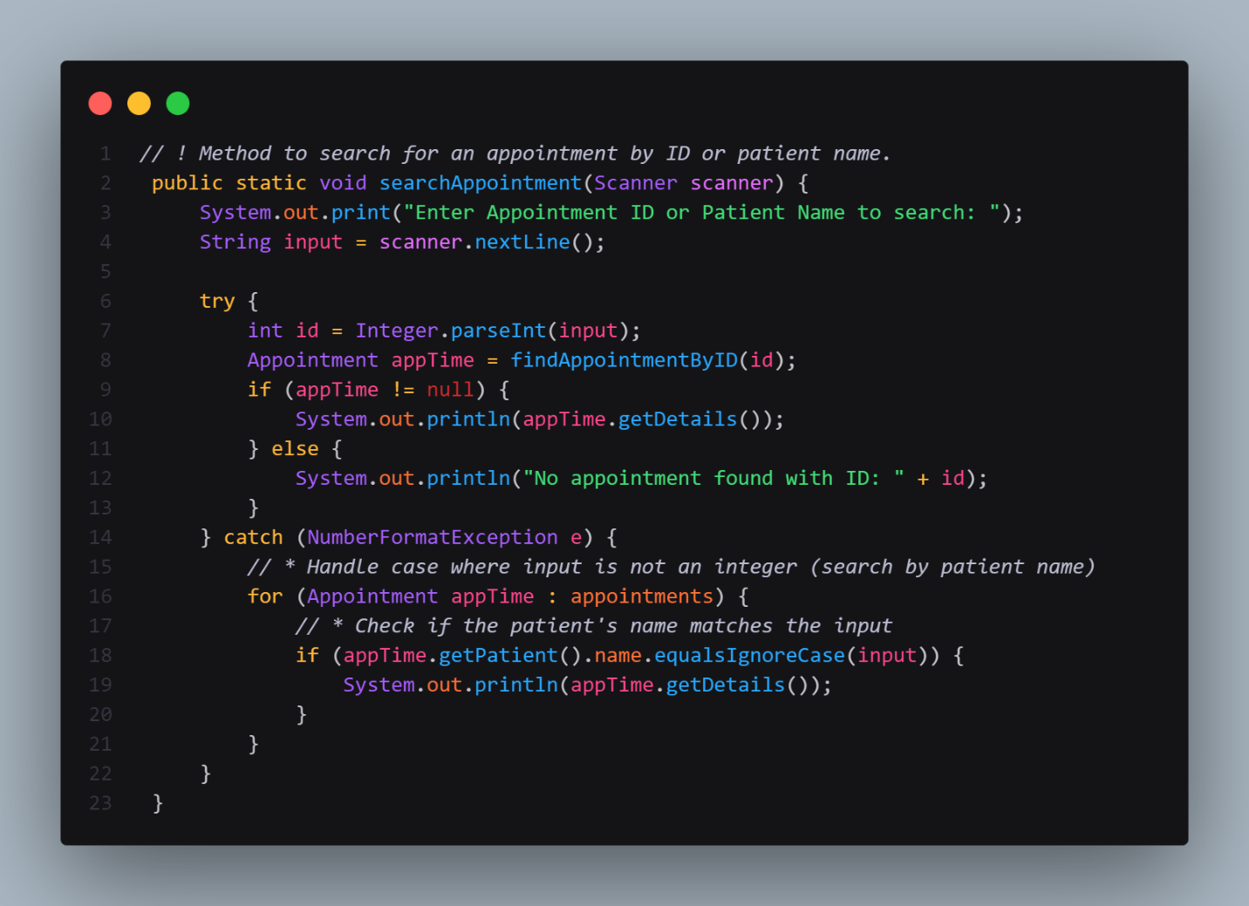

Figure 28 Code Snippet 12 - Search Appointment by Patient Name / Appointment ID Method

**Input Handling:**

* Prompts the user to enter an appointment ID or patient name to search for.
* Stores the user's input in a string variable.

**Search Logic:**

* **Search by ID:**
  + Attempts to parse the input as an integer.
  + If successful, calls the findAppointmentById method to locate the appointment with the given ID.
  + If the appointment is found, its details are printed.
  + If the appointment is not found, an error message is displayed.

**Error Handling:**

* Uses a try-catch block to handle potential NumberFormatException errors if the input cannot be parsed as an integer.
* Provides informative error messages for both ID-based and name-based searches.

#### Cancel Appointment Method

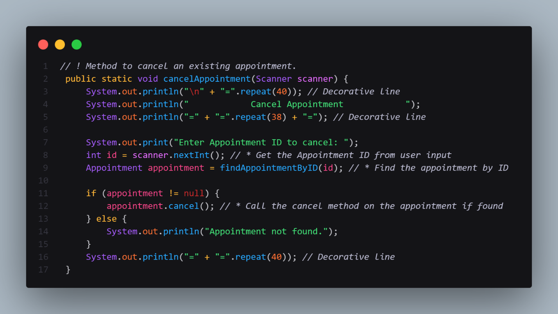

Figure 29 Code Snippet 13 - Cancel Appointment Method

**Input Handling:**

* Prompts the user to enter the appointment ID to be canceled.
* Reads the input and stores it in an integer variable.

**Search Logic:**

* Calls the findAppointmentById method to locate the appointment with the specified ID.
* Iterates through the list of appointments to find a match based on the ID.

**Object Modification:**

* If the appointment is found, the cancel() method is called on the appointment object to set its status to "CANCELED".

**Error Handling:**

* Checks if the appointment with the given ID exists.
* If the appointment is not found, an error message is displayed.

**Output:**

* Prints a confirmation message if the cancellation is successful.
* Prints an error message if the appointment is not found.

### Treatment Class

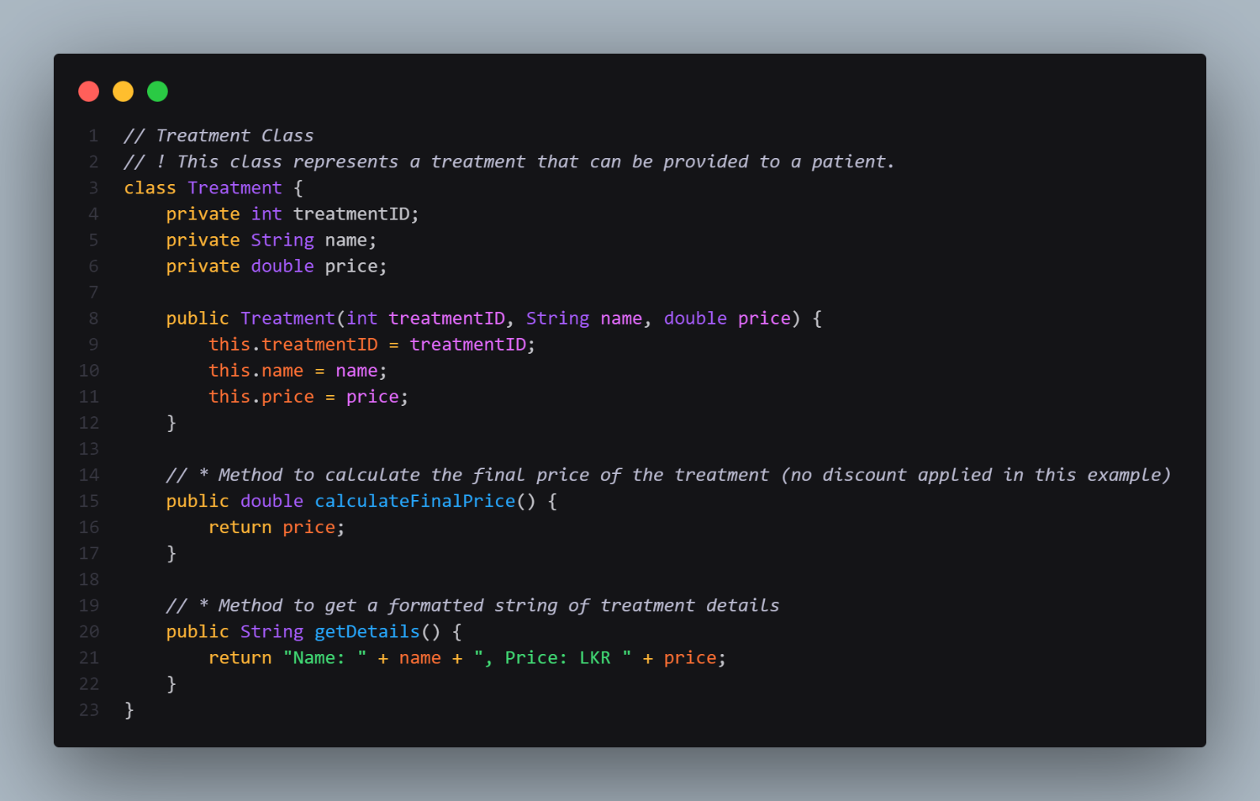

Figure 30 Code Snippet 14 - Treatment Class

The Treatment class represents medical treatments within a healthcare application, capturing key information about each treatment. It includes a constructor to initialize a treatment with a treatmentID, name, and price. The calculateFinalPrice() method provides the treatment's cost, while getDetails() returns a formatted string containing the treatment’s name and price.

This class allows for the management of different treatments, including options like Acne Treatment (2750.00), Skin Whitening (7650.00), Mole Removal (3850.00), and Laser Treatment (12,500.00), offering a foundational structure for handling treatment details and pricing within the system.

### Payment Class

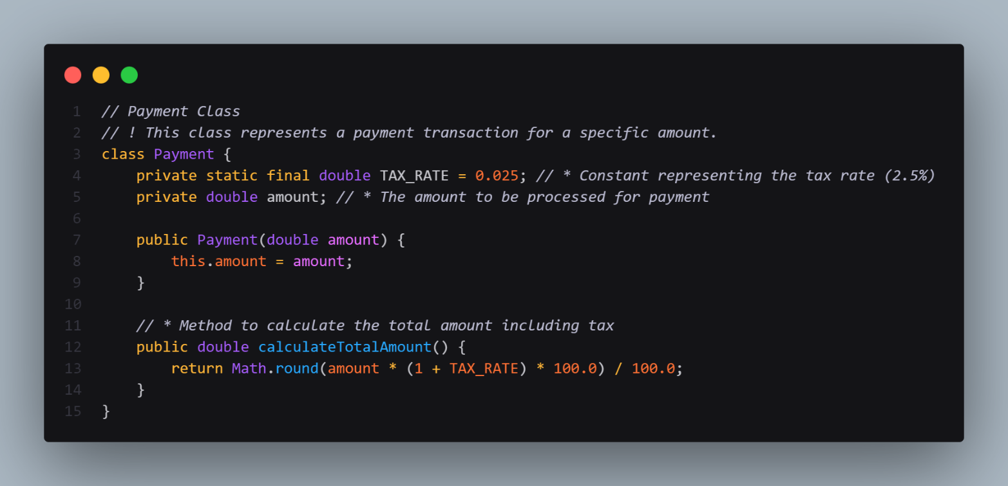

Figure 31 Code Snippet 15 - Payment Class

The Payment class models a payment transaction within a system, focusing on processing an amount with tax calculations. It includes a constant TAX_RATE of 2.5% and an amount field for the payment amount. The constructor initializes the payment with a specified amount, while the calculateTotalAmount() method calculates the total amount including tax by applying the tax rate and rounding the result to two decimal places. This class offers a straightforward structure for handling payments and accurately determining the total transaction amount with tax included.

* **Tax Calculation**: The class ensures that any payment transaction accurately includes the tax amount, offering a straightforward way to compute the total transaction value.
* **Clear Constructor Initialization**: The constructor initializes the payment with a given amount, making it easy to instantiate and manage payment records.
* **Efficient Total Calculation**: The method calculateTotalAmount() calculates the full amount due, ensuring the tax is applied and the total is rounded to two decimal places, which is crucial for financial transactions.

### Invoice Class

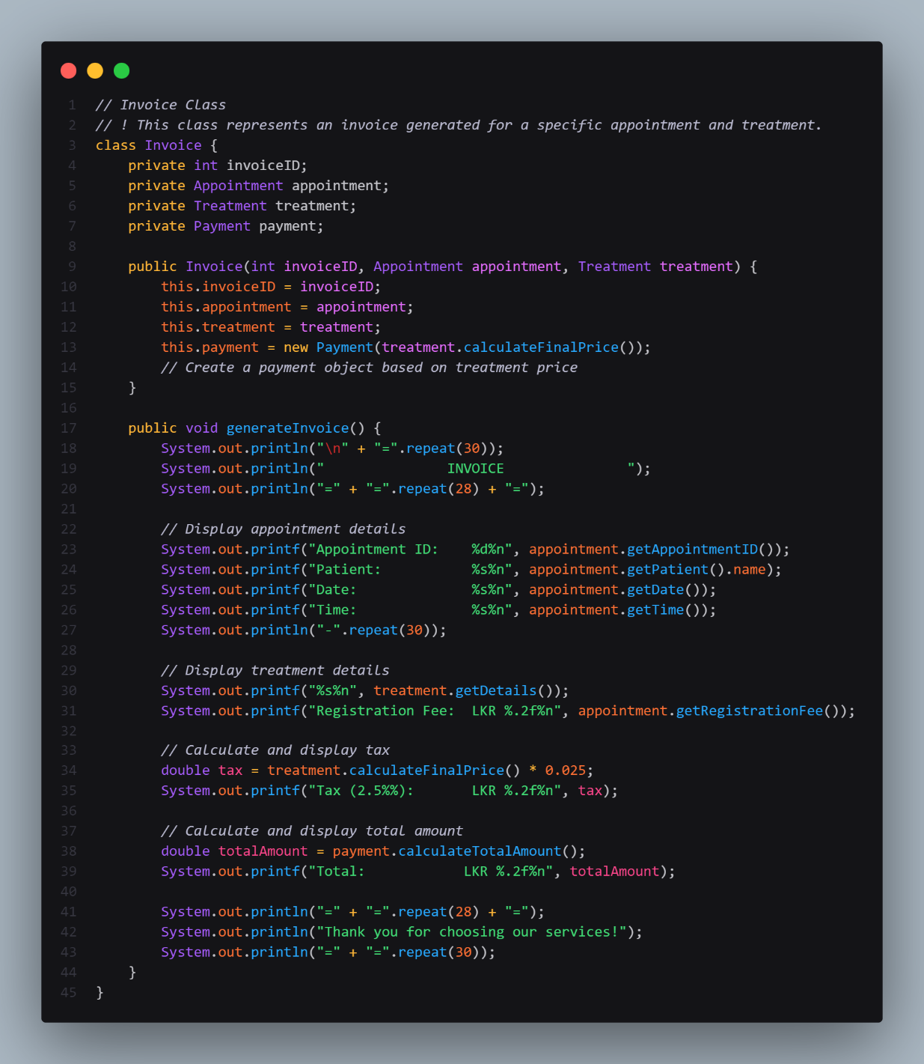

Figure 32 Code Snippet 16 - Invoice Class

The Invoice class models an invoice for a specific appointment and treatment, enabling organized billing within a healthcare system. It contains fields for a unique invoiceID, the associated Appointment and Treatment objects, and a Payment object based on the treatment's price. The constructor initializes the invoice with these details. Through the generateInvoice() method, it produces a formatted invoice that includes the appointment ID, patient name, date, time, treatment name, treatment price, registration fee, tax (2.5% of the treatment price), and total amount (treatment price plus tax), ending with a thank-you message. This class provides a comprehensive structure for generating clear, itemized invoices for appointments, facilitating accurate billing and payment processing.

#### Generate Invoice Method

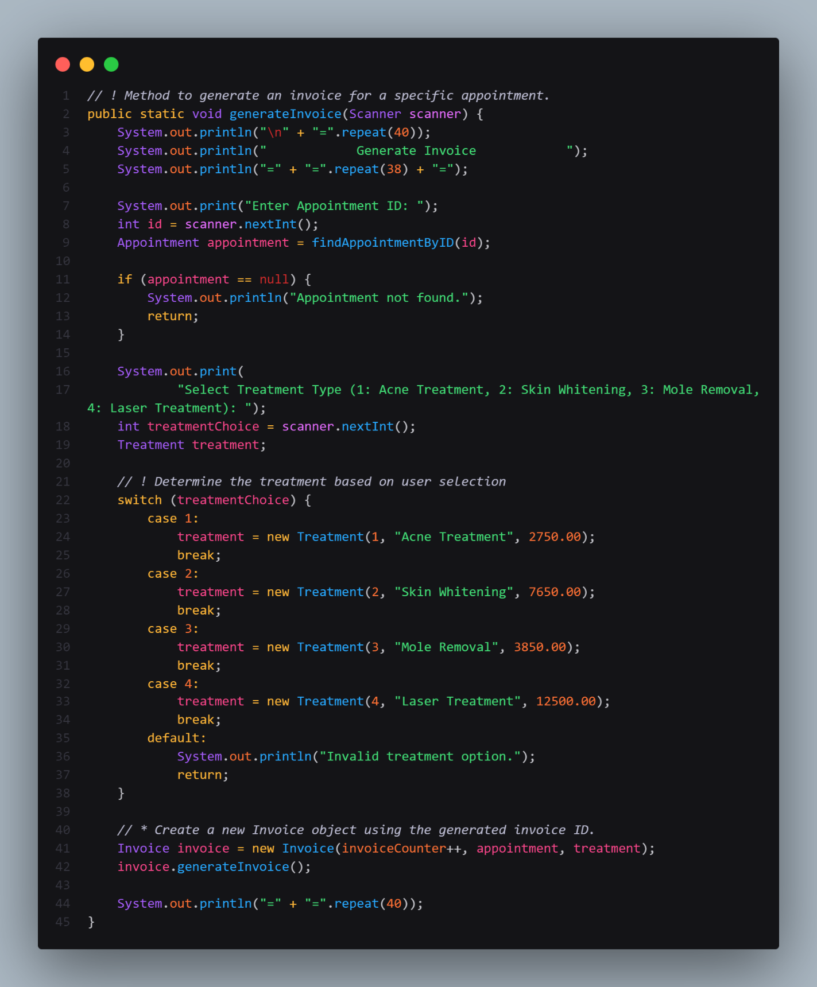

Figure 33 Code Snippet 17 - Generate Invoice Method

**Input Handling:**

* Prompts the user to enter the appointment ID.
* Validates the appointment ID by searching for the corresponding appointment in the list.

**Treatment Selection:**

* Displays a list of available treatment options.
* Prompts the user to select a treatment type.
* Creates a Treatment object based on the user's choice.

**Invoice Generation:**

* Creates a new Invoice object with the generated invoice ID, the selected appointment, and the chosen treatment.
* Calls the generateInvoice() method of the Invoice object to print the invoice details, including:
  + Appointment details (ID, date, time, patient, doctor)
  + Treatment details (name, price)
  + Tax amount (calculated based on the treatment price)
  + Total amount (treatment price + tax)

**Error Handling:**

* Checks if the appointment with the given ID exists.
* If the appointment is not found, an error message is displayed.
* Validates the user's treatment choice and displays an error message for invalid choices.

## Effective use of Object-Oriented Programming (OOP) concepts

### Encapsulation

The **Person** class encapsulates the basic contact information of a person (name, email, and contact number) and provides a method **getContactInfo()** to access this information without exposing the data directly.

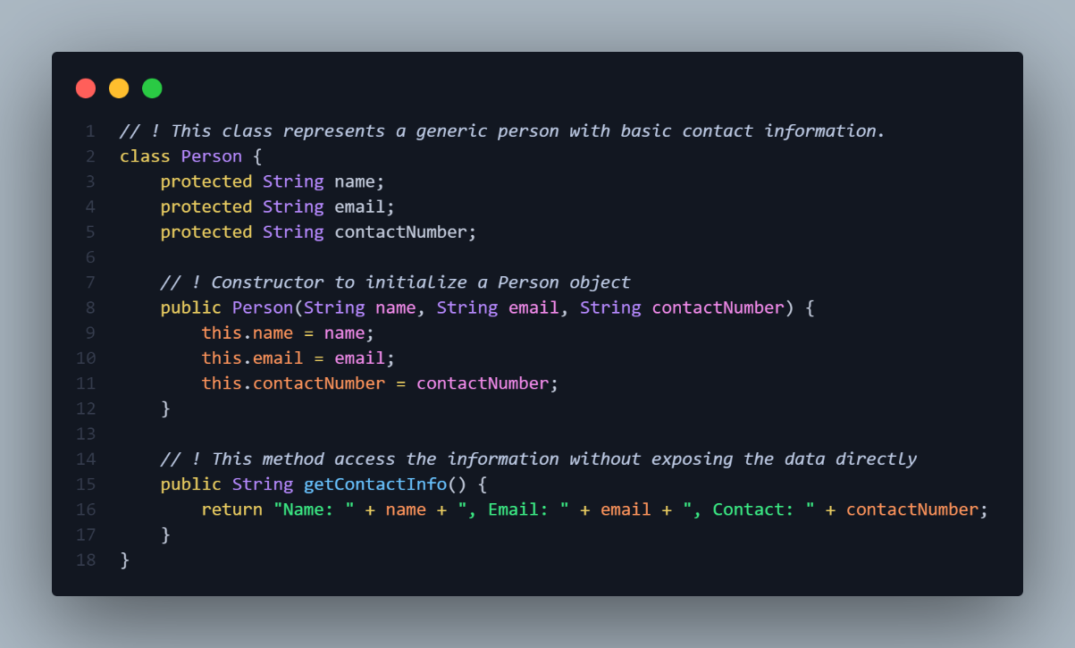

Figure 34 Code Snippet 18 – Encapsulation of OOP Concept

### Inheritance

The **Patient** and **Doctor** classes extend the **Person** class, inheriting its attributes and methods. This allows both **Patient** and **Doctor** to have the basic contact information without needing to redefine it.

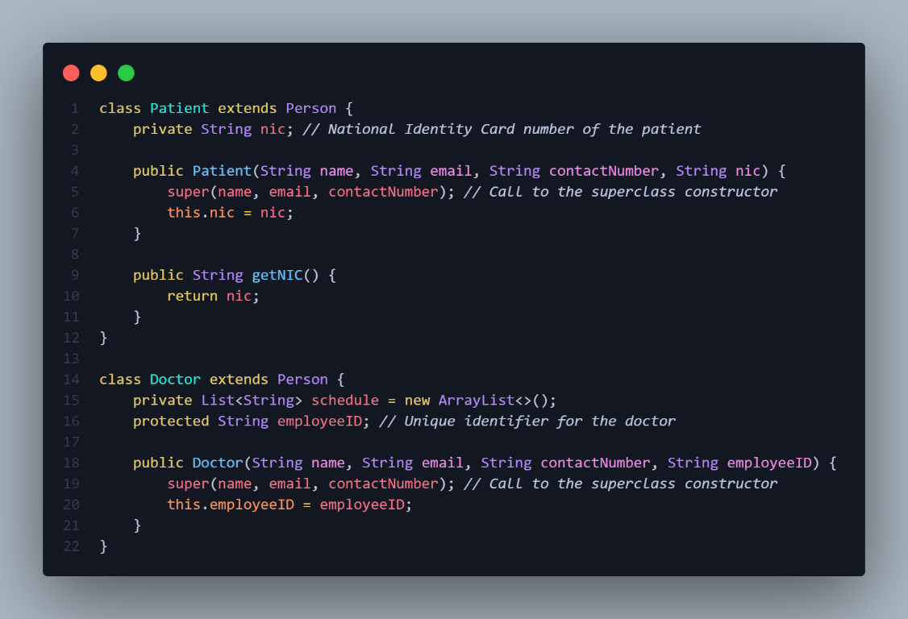

Figure 35 Code Snippet 18 – Inheritance of OOP Concept

### Polymorphism

The **getDetails()** method in the **Appointment** class provides a way to get formatted details of the appointment. Although the method name is the same, it operates on different types of objects (i.e., **Appointment**, **Patient**, **Doctor**).

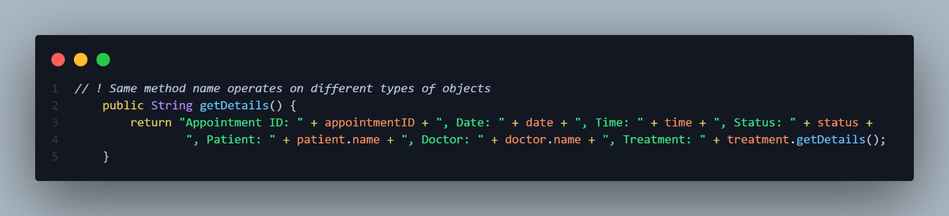

Figure 36 Code Snippet 18 – Polymorphism of OOP Concept

### Abstraction

The **Invoice** class abstracts the details of generating an invoice, allowing users to generate an invoice without needing to understand the underlying calculations for taxes and totals.

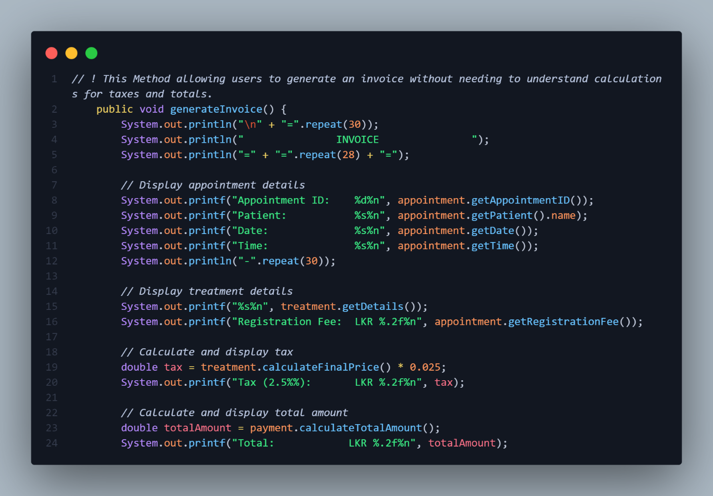

Figure 37 Code Snippet 18 – Abstraction of OOP Concept

## Effective use of Data Structures

### Classes as Data Structures

The **Appointment** class organizes related data (appointment details) and methods.

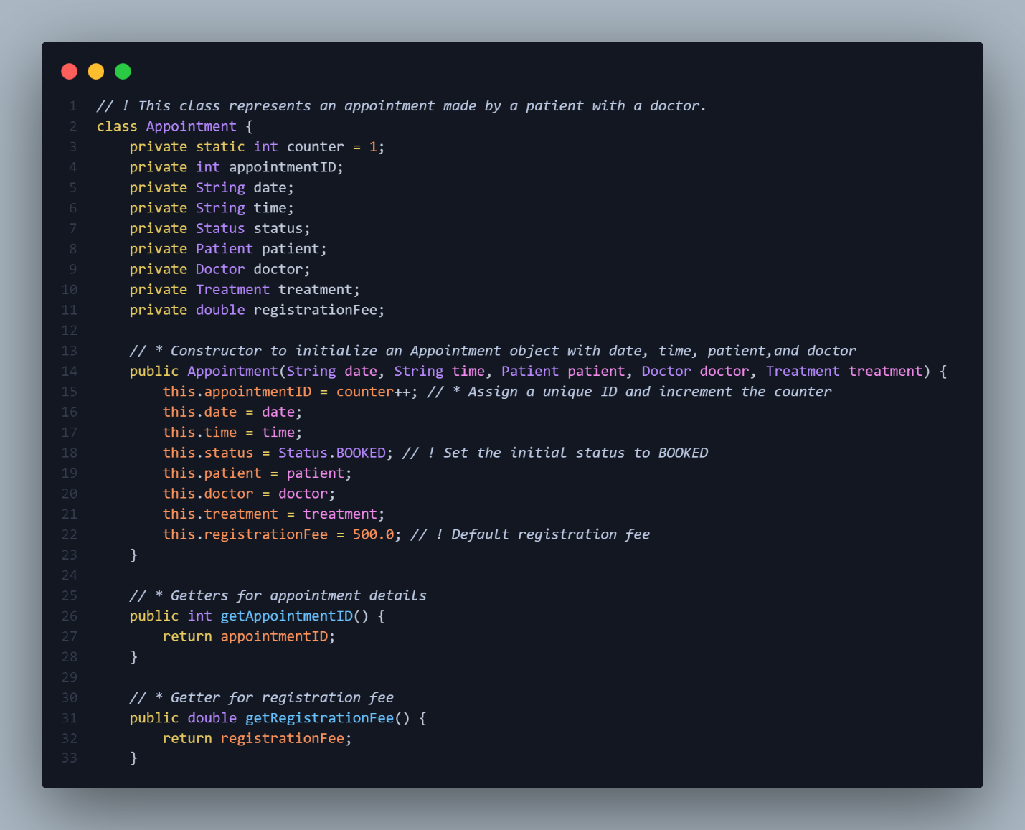

Figure 38 Code Snippet 19 – Classes as Data Structures

### Collections Framework

The **AuroraSkinCare** class uses an **ArrayList** to manage multiple objects, showcasing the use of a collection.

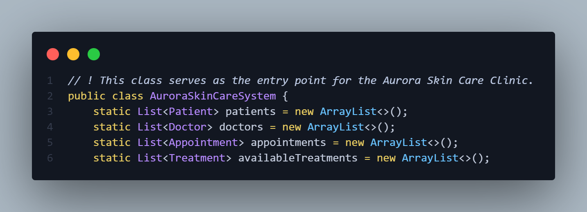

Figure 39 Code Snippet 20 – Collections Framework of Data Structure

### Encapsulation of Data

The **Treatment** class encapsulates treatment details and provides methods for accessing and manipulating that data.

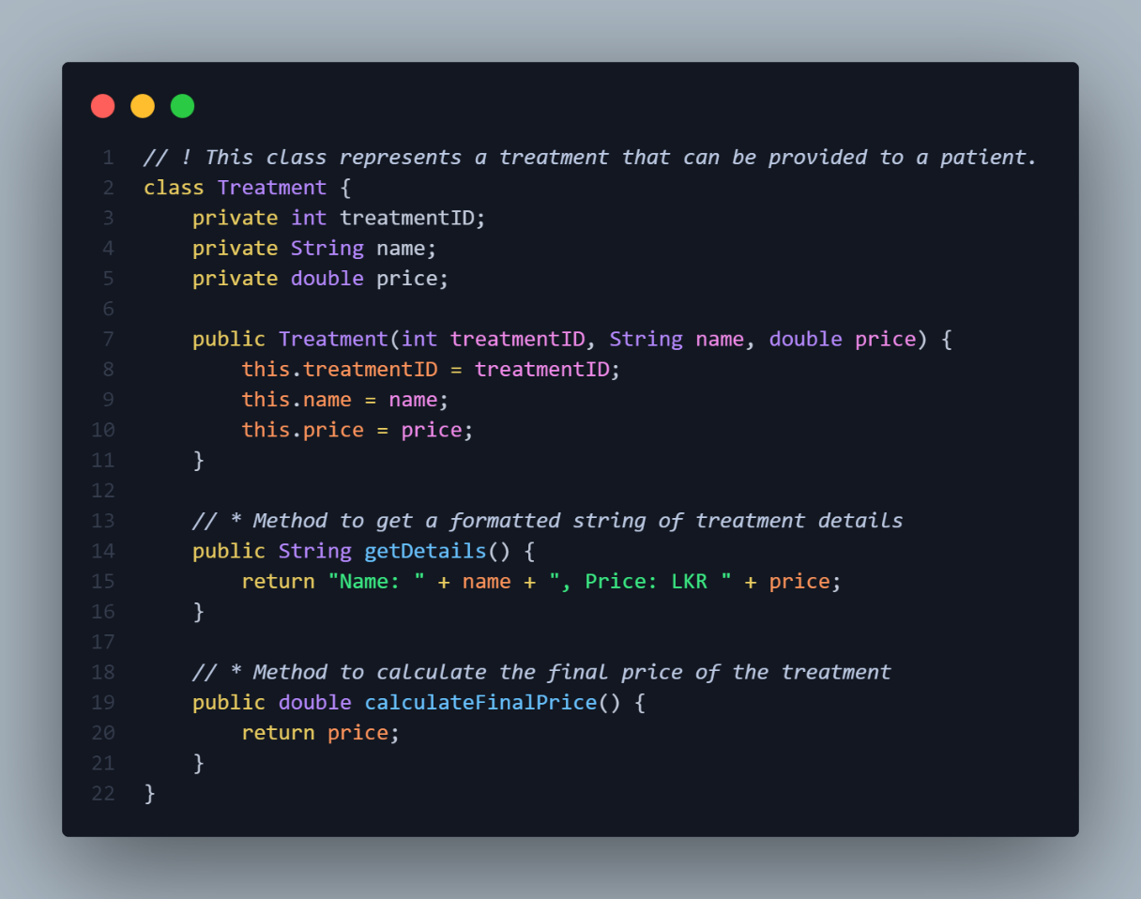

Figure 40 Code Snippet 21 – Encapsulation of Data of Data Structure

### Use of Primitive Types

The **Payment** class uses **double** for fees and tax rates, demonstrating the use of primitive types for basic data handling.

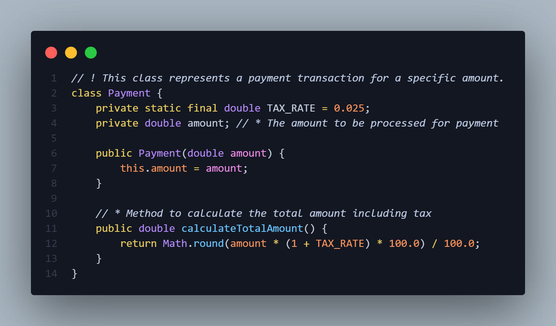

Figure 41 Code Snippet 22 - Uses of Primitive Types of Data Structure

## Effective use of Algorithms

### **Searching Algorithms:** Searching for a Patient by NIC or Name

This method uses Java Streams, which provide a high-level abstraction for processing sequences of elements. The **filter** operation applies a predicate to each element in the **patients** list, efficiently narrowing down the results to find the first patient that matches the provided NIC.

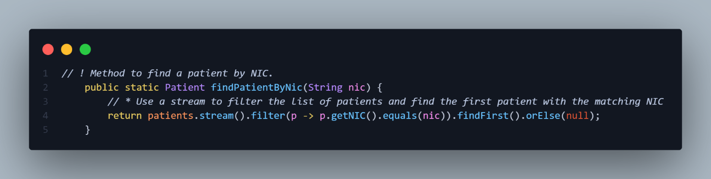

Figure 42 Code Snippet 23 - Searching Algorithms

### Data Manipulation Algorithms: Adding a New Appointment

When adding a new appointment, the **add()** method of **ArrayList** is utilized. This method is efficient as it typically operates in constant time, O(1), unless the internal array needs to be resized (which happens infrequently).

The algorithm behind **ArrayList** manages dynamic resizing and ensures that the addition of new elements remains efficient.

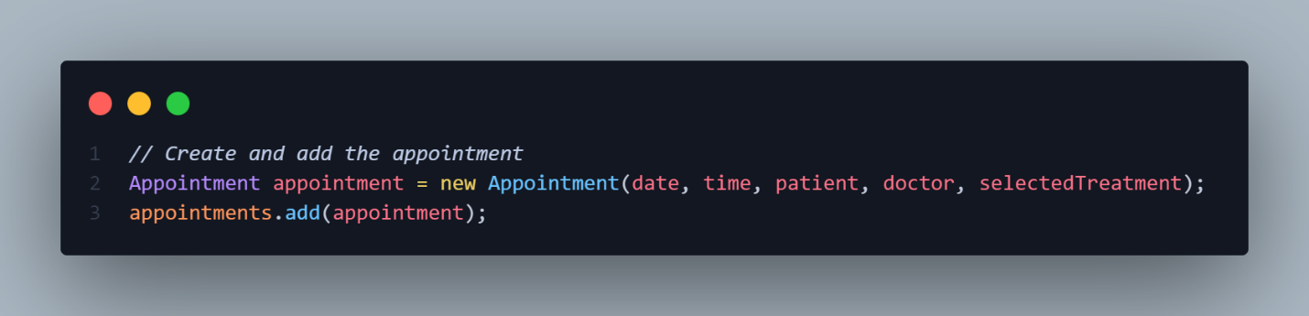

Figure 43 Code Snippet 24 - Data Manipulation Algorithms

### Invoice Generation Algorithms: Calculating Total Amounts

The **calculateTotalAmount()** method demonstrates a simple mathematical algorithm for calculating the total amount including tax. The use of **Math.round()** ensures that the result is rounded to two decimal places, which is crucial for financial calculations.

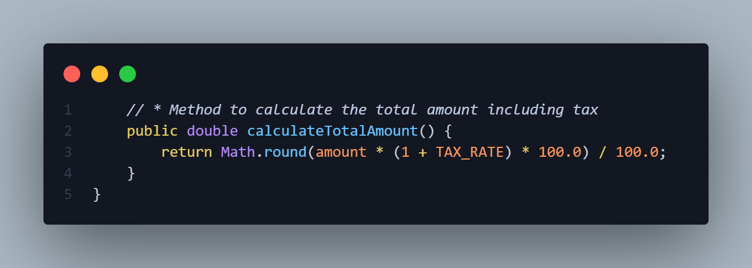

Figure 44 Code Snippet 25 - Invoice Generation Algorithms

# Activity 04 – Testing & Conclusion

## Black-Box Testing

The Aurora Skin Care System underwent rigorous testing to ensure its functionality and usability. This testing involved a combination of black-box and validation techniques.

Black-box testing focused on evaluating the system's behavior from an end-user perspective. By interacting with the command-line interface (CLI) and observing the system's responses to various inputs, the author verified that each function operated as expected, aligning with the system's specifications. This approach effectively simulated real-world user interactions.

Validation testing concentrated on confirming that the system met its requirements and performed its intended functions efficiently. The author meticulously examined the system's responses to user commands, ensuring that patient registration, appointment scheduling, and invoice generation were accurate and reliable. This testing method helped identify any discrepancies between the system's behavior and user expectations, ensuring that the system functioned effectively in various scenarios.

By combining black-box and validation testing, the author established a comprehensive testing strategy that addressed both technical and user-centric aspects of the system. This approach enhanced the system's quality, reliability, and user-friendliness. The synergy of these two testing methods played a crucial role in identifying and rectifying functional issues and usability gaps, ultimately resulting in a robust and efficient Aurora Skin Care System that met the needs of both the clinic and its users.

## Unit Testing: Test Cases for Aurora Skin Care

### Patient Related Test Cases

|  |  |
| --- | --- |
| Test Case 01 – Register New Patient | |
| **Test ID** | TC - 001 |
| **Test Name** | Register New Patient |
| **Steps to Test** | 1. Start the Aurora Skin Care system.  2. Select the option "Register Patient".  3. Enter all required patient details (Name, NIC, Contact).  4. Confirm registration. |
| **Pre-defined Function** | None |
| **Post-defined Function** | Search Patient by NIC |
| **Date of Testing** | 2024-11-08 |
| **Expected Outcome** | New patient is successfully registered, and confirmation message is displayed. |
| **Actual Outcome** |  |
| **Test Status** | Pass |
| **Name of the Tester** | A.A.M Aathif |
| **Comments** | Check if all mandatory fields are validated. |

Table 1 Test Case 01 Patient - Register New Patient

|  |  |
| --- | --- |
| Test Case 02 – Search Patient by NIC | |
| **Test ID** | TC - 002 |
| **Test Name** | Search Patient by NIC |
| **Steps to Test** | 1. Start the Aurora Skin Care system.  2. Select the option "Search Patient by Name or NIC". 3. Enter a valid NIC. 4. Verify if the correct patient details are displayed. |
| **Pre-defined Function** | Register New Patient |
| **Post-defined Function** | Search Patient by Name |
| **Date of Testing** | 2024-11-08 |
| **Expected Outcome** | System retrieves and displays the correct patient details based on NIC. |
| **Actual Outcome** |  |
| **Test Status** | Pass |
| **Name of the Tester** | A.A.M Aathif |
| **Comments** | Test with both existing and non-existing NIC values. |

Table 2 Test Case 02 Patient - Search Patient by NIC

|  |  |
| --- | --- |
| Test Case 03 – Search Patient by Name | |
| **Test ID** | TC - 003 |
| **Test Name** | Search Patient by Name |
| **Steps to Test** | 1. Start the Aurora Skin Care system.  2. Select the option "Search Patient by Name or NIC". 3. Enter the Patient Name Correctly. 4. Verify if the correct patient details are displayed. |
| **Pre-defined Function** | Search Patient by NIC |
| **Post-defined Function** | Invalid NIC for Search |
| **Date of Testing** | 2024-11-08 |
| **Expected Outcome** | System retrieves and displays the correct patient details based on Name. |
| **Actual Outcome** |  |
| **Test Status** | Pass |
| **Name of the Tester** | A.A.M Aathif |
| **Comments** | Test with both partial and full names. |

Table 3 Test Case 03 Patient - Search Patient by Name

|  |  |
| --- | --- |
| Test Case 04 – Invalid NIC for Search | |
| **Test ID** | TC - 004 |
| **Test Name** | Invalid NIC for Search |
| **Steps to Test** | 1. Start the Aurora Skin Care system.  2. Select the option "Search Patient by Name or NIC".  3. Enter an invalid NIC (e.g., incomplete or incorrectly formatted NIC). |
| **Pre-defined Function** | Search Patient by NIC |
| **Post-defined Function** | Search Doctor by ID |
| **Date of Testing** | 2024-11-08 |
| **Expected Outcome** | System retrieves and displays the correct patient details based on NIC. |
| **Actual Outcome** |  |
| **Test Status** | Pass |
| **Name of the Tester** | A.A.M Aathif |
| **Comments** | Verify system handling for different invalid NIC formats. |

Table 4 Test Case 04 Patient - Invalid NIC for Search

### Doctor-Related Test Cases

|  |  |
| --- | --- |
| Test Case 05 – Search Doctor by ID | |
| **Test ID** | TC - 005 |
| **Test Name** | Search Doctor by ID |
| **Steps to Test** | 1. Start the system.  2. Select "Search Doctor by Name or ID".  3. Enter a valid doctor ID. |
| **Pre-defined Function** | Invalid NIC for Search |
| **Post-defined Function** | Search Doctor by Name |
| **Date of Testing** | 2024-11-08 |
| **Expected Outcome** | Doctor details are displayed for the entered ID. |
| **Actual Outcome** |  |
| **Test Status** | Pass |
| **Name of the Tester** | A.A.M Aathif |
| **Comments** | Test with both valid and invalid doctor IDs. |

Table 5 Test Case 05 Doctor - Search Doctor by ID

|  |  |
| --- | --- |
| Test Case 06 – Search Doctor by Name | |
| **Test ID** | TC - 006 |
| **Test Name** | Search Doctor by Name |
| **Steps to Test** | 1. Start the system.  2. Select "Search Doctor by Name or ID".  3. Enter a valid doctor name. |
| **Pre-defined Function** | Search Doctor by ID |
| **Post-defined Function** | Invalid Doctor ID |
| **Date of Testing** | 2024-11-08 |
| **Expected Outcome** | Doctor details are displayed for the entered name. |
| **Actual Outcome** |  |
| **Test Status** | Pass |
| **Name of the Tester** | A.A.M Aathif |
| **Comments** | Test with both partial and full names. |

Table 6 Test Case 06 Doctor - Search Doctor by Name

|  |  |
| --- | --- |
| Test Case 07 – Invalid Doctor ID | |
| **Test ID** | TC - 007 |
| **Test Name** | Invalid Doctor ID |
| **Steps to Test** | 1. Start the system.  2. Select "Search Doctor by Name or ID".  3. Enter an invalid doctor ID. |
| **Pre-defined Function** | Search Doctor by Name |
| **Post-defined Function** | Invalid Doctor ID |
| **Date of Testing** | 2024-11-08 |
| **Expected Outcome** | System displays "Doctor not found" message. |
| **Actual Outcome** |  |
| **Test Status** | Pass |
| **Name of the Tester** | A.A.M Aathif |
| **Comments** | Test with a variety of invalid formats. |

Table 7 Test Case 07 Doctor - Invalid Doctor ID

|  |  |
| --- | --- |
| Test Case 08 – Invalid Doctor Name | |
| **Test ID** | TC - 008 |
| **Test Name** | Invalid Doctor Name |
| **Steps to Test** | 1. Start the system.  2. Select "Search Doctor by Name or ID".  3. Enter an invalid doctor Name. |
| **Pre-defined Function** | Invalid Doctor ID |
| **Post-defined Function** | Make Appointment |
| **Date of Testing** | 2024-11-08 |
| **Expected Outcome** | System displays "Doctor not found" message. |
| **Actual Outcome** |  |
| **Test Status** | Pass |
| **Name of the Tester** | A.A.M Aathif |
| **Comments** | Test with a variety of invalid formats. |

Table 8 Test Case 08 Doctor - Invalid Doctor Name

### Appointment-Related Test Cases

|  |  |
| --- | --- |
| Test Case 09 – Make Appointment | |
| **Test ID** | TC - 009 |
| **Test Name** | Make Appointment |
| **Steps to Test** | 1. Start the system.  2. Select "Make Appointment".  3. Enter patient details, doctor, date, and time. |
| **Pre-defined Function** | Invalid Doctor Name |
| **Post-defined Function** | View Appointment by Date |
| **Date of Testing** | 2024-11-08 |
| **Expected Outcome** | Appointment is successfully created. |
| **Actual Outcome** |  |
| **Test Status** | Pass |
| **Name of the Tester** | A.A.M Aathif |
| **Comments** | Appointment is successfully created. |

Table 9 Test Case 09 Appointment - Make Appointment

|  |  |
| --- | --- |
| Test Case 10 – View Appointment by Date | |
| **Test ID** | TC – 010 |
| **Test Name** | View Appointment by Date |
| **Steps to Test** | |  | | --- | |  |   1. Start the system.  2. Select "View Appointment Details by Date".  3. Enter a specific date to view appointments. |
| **Pre-defined Function** | Make Appointment |
| **Post-defined Function** | Update Appointment Details |
| **Date of Testing** | 2024-11-08 |
| **Expected Outcome** | Appointment Found. and Display Appointment Details |
| **Actual Outcome** |  |
| **Test Status** | Pass |
| **Name of the Tester** | A.A.M Aathif |
| **Comments** | Verify list displays all entries for that date. |

Table 10 Test Case 10 Appointment - View Appointment Details by Date

|  |  |
| --- | --- |
| Test Case 11 – Update Appointment Details | |
| **Test ID** | TC – 011 |
| **Test Name** | Update Appointment Details |
| **Steps to Test** | 1. Start the system.  2. Select "Update Appointment Details".  3. Enter New Date.  4. Enter New Time.  5. Press Enter to Update Appointment. |
| **Pre-defined Function** | View Appointment by Date |
| **Post-defined Function** | Search Appointment by Name / Appointment ID |
| **Date of Testing** | 2024-11-08 |
| **Expected Outcome** | |  | | --- | |  |   Appointment Updated Successfully. |
| **Actual Outcome** |  |
| **Test Status** | Pass |
| **Name of the Tester** | A.A.M Aathif |
| **Comments** | Verify that updated information reflects in Appointment records. |

Table 11 Test Case 11 Appointment - Update Appointment Details

|  |  |
| --- | --- |
| Test Case 12 – Search Appointment by Name / Appointment ID | |
| **Test ID** | TC – 012 |
| **Test Name** | Search Appointment by Name / Appointment ID |
| **Steps to Test** | 1. Start the system.  2. Select "Search Appointment by Name / ID".  3. Enter Appointment ID. |
| **Pre-defined Function** | Update Appointment Details |
| **Post-defined Function** | Cancel Appointment |
| **Date of Testing** | 2024-11-08 |
| **Expected Outcome** | |  | | --- | |  |   Appointment Updated Successfully. |
| **Actual Outcome** |  |
| **Test Status** | Pass |
| **Name of the Tester** | A.A.M Aathif |
| **Comments** | Verify that updated information reflects in Appointment records. |

Table 12 Test Case 12 Appointment - Search Appointment by Name / Appointment ID

|  |  |
| --- | --- |
| Test Case 13 – Cancel Appointment | |
| **Test ID** | TC – 013 |
| **Test Name** | Cancel Appointment |
| **Steps to Test** | |  | | --- | |  |   1. Start the system.  2. Select “Cancel Appointment” |
| **Pre-defined Function** | Search Appointment by Name / Appointment ID |
| **Post-defined Function** | Invalid Appointment Date |
| **Date of Testing** | 2024-11-08 |
| **Expected Outcome** | Appointment is successfully cancelled. |
| **Actual Outcome** |  |
| **Test Status** | Pass |
| **Name of the Tester** | A.A.M Aathif |
| **Comments** | Check if appointment slot is freed up after cancellation. |

Table 13Test Case 13 Appointment - Cancel Appointment

|  |  |
| --- | --- |
| Test Case 14 – Invalid Appointment Date | |
| **Test ID** | TC – 014 |
| **Test Name** | Invalid Appointment Date |
| **Steps to Test** | 1. Start the system.  2. Select "Make Appointment".  3. Enter an invalid or past date. |
| **Pre-defined Function** | Cancel Appointment |
| **Post-defined Function** | View Appointment by Invalid Date |
| **Date of Testing** | 2024-11-08 |
| **Expected Outcome** | System displays error message about invalid date. |
| **Actual Outcome** |  |
| **Test Status** | Pass |
| **Name of the Tester** | A.A.M Aathif |
| **Comments** | Test with both past and non-date formats. |

Table 14 Test Case 14 Appointment - Invalid Appointment Date

|  |  |
| --- | --- |
| Test Case 15 – View Appointment by Invalid Date | |
| **Test ID** | TC – 015 |
| **Test Name** | View Appointment by Invalid Date |
| **Steps to Test** | |  | | --- | |  |   1. Start the system.  2. Select "View Appointment Details by Date".  3. Enter an invalid or past date. |
| **Pre-defined Function** | Invalid Appointment Date |
| **Post-defined Function** | Search Appointment by Invalid Appointment ID |
| **Date of Testing** | 2024-11-08 |
| **Expected Outcome** | System displays error message about invalid date. |
| **Actual Outcome** |  |
| **Test Status** | Pass |
| **Name of the Tester** | A.A.M Aathif |
| **Comments** | Verify list displays all entries for that date. |

Table 15 Test Case 15 Appointment - View Appointment by Invalid Date

|  |  |
| --- | --- |
| Test Case 16 – Search Appointment by Invalid Appointment ID | |
| **Test ID** | TC – 016 |
| **Test Name** | Search Appointment by Name / Appointment ID |
| **Steps to Test** | 1. Start the system.  2. Select "Search Appointment by Name / ID".  3. Enter Invalid ID. |
| **Pre-defined Function** | View Appointment by Invalid Date |
| **Post-defined Function** | Cancel Non-Existent Appointment |
| **Date of Testing** | 2024-11-08 |
| **Expected Outcome** | |  | | --- | |  |   No Appointment found with ID. |
| **Actual Outcome** |  |
| **Test Status** | Pass |
| **Name of the Tester** | A.A.M Aathif |
| **Comments** | Verify list displays all Appointment ID’s. |

Table 16 Test Case 16 Appointment - Search Appointment by Name / Appointment ID

|  |  |
| --- | --- |
| Test Case 17 – Cancel Non-Existent Appointment | |
| **Test ID** | TC – 017 |
| **Test Name** | Cancel Non-Existent Appointment |
| **Steps to Test** | 1. Start the system.  2. Select "Cancel Appointment".  3. Enter Invalid ID. |
| **Pre-defined Function** | Search Appointment by Name / Appointment ID |
| **Post-defined Function** | Calculate Total Amount with Tax |
| **Date of Testing** | 2024-11-08 |
| **Expected Outcome** | |  | | --- | |  |   No Appointment found with ID. |
| **Actual Outcome** |  |
| **Test Status** | Pass |
| **Name of the Tester** | A.A.M Aathif |
| **Comments** | Verify list displays all Appointment ID’s. |

Table 17 Test Case 17 Appointment - Cancel Non-Existent Appointment

### Payment-Related Test Cases

|  |  |
| --- | --- |
| Test Case 18 – Calculate Total Amount with Tax | |
| **Test ID** | TC – 018 |
| **Test Name** | Calculate Total Amount with Tax |
| **Steps to Test** | 1. Start payment for a treatment.  2. Select Treatment Type.  3. Press Enter to Generate Invoice. |
| **Pre-defined Function** | Cancel Non-Existent Appointment |
| **Post-defined Function** | Generate Invoice |
| **Date of Testing** | 2024-11-08 |
| **Expected Outcome** | Select Treatment Type, and confirmation is displayed. |
| **Actual Outcome** |  |
| **Test Status** | Pass |
| **Name of the Tester** | A.A.M Aathif |
| **Comments** | Test with different treatment types if available. |

Table 18 Test Case 18 Payment - Calculate Total Amount with Tax

|  |  |
| --- | --- |
| Test Case 19 – Generate Invoice | |
| **Test ID** | TC – 019 |
| **Test Name** | Generate Invoice |
| **Steps to Test** | 1. Enter Appointment ID.  2. Generate invoice. |
| **Pre-defined Function** | Calculate Total Amount with Tax |
| **Post-defined Function** | Generate Invoice by Invalid ID |
| **Date of Testing** | 2024-11-08 |
| **Expected Outcome** | |  | | --- | |  |   Invoice is generated and saved. |
| **Actual Outcome** |  |
| **Test Status** | Pass |
| **Name of the Tester** | A.A.M Aathif |
| **Comments** | Verify that the invoice includes all details. |

Table 19 Test Case 19 Payment - Generate Invoice

|  |  |
| --- | --- |
| Test Case 20 – Generate Invoice by Invalid ID | |
| **Test ID** | TC – 020 |
| **Test Name** | Generate Invoice by Invalid ID |
| **Steps to Test** | 1. Select "Generate Invoice".  2. Enter Invalid Appointment ID. |
| **Pre-defined Function** | Generate Invoice |
| **Post-defined Function** | None |
| **Date of Testing** | 2024-11-08 |
| **Expected Outcome** | |  | | --- | |  |   Appointment Not Found. |
| **Actual Outcome** |  |
| **Test Status** | Pass |
| **Name of the Tester** | A.A.M Aathif |
| **Comments** | Test with non-existent Appointment IDs and invalid formats. |

Table 20 Test Case 20 Payment - Generate Invoice by Invalid ID

## Discussion: Key Challenges Encountered

### NullPointerException when Accessing Patient / Doctor Information

**Issue:** The application encountered a **NullPointerException** *(Figure 45)* when attempting to access the name field of a Patient object that was null. This error occurred because the specified patient was not found in the system.

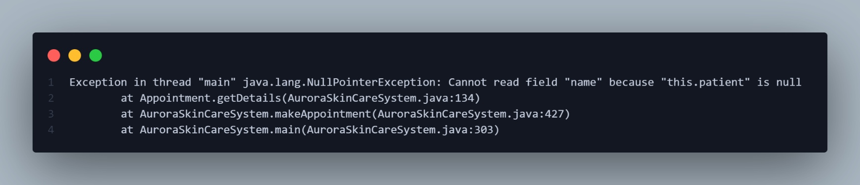

Figure 45 Error 01 - NullPointerException

**Solution:** To resolve this issue, the code was modified to check if the **Patient** object is **null** before accessing its **Name** field *(Figure 46)*. If the **Patient** object is **null**, an informative error message is displayed, indicating that the patient is not found and needs to be registered first.

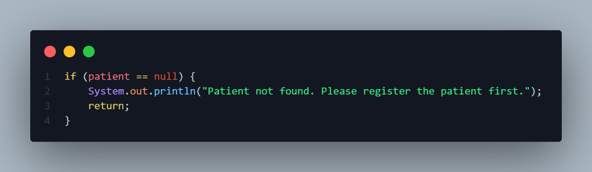

Figure 46 Solution 01 - Null Check and Error Handling

With this solution, the program now displays a clear and informative error message *(Figure 47)* when the patient is not found, guiding the user to register the patient before making an appointment. This significantly improves the user experience and prevents the program from crashing due to unexpected null values.

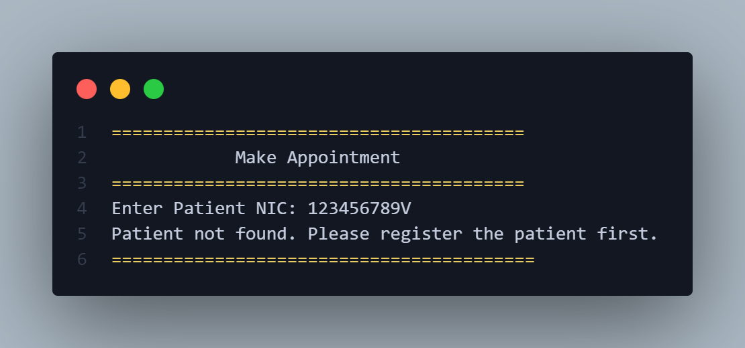

Figure 47 Output 01 - Informative Error Message

### IndexOutOfBoundsException in Treatment Selection

**Issue:** The application encountered an **IndexOutOfBoundsException** *(Figure 48)* when the user provided an invalid treatment selection, such as entering "5" when only options 1-4 were available. This error disrupted the program's flow and displayed an uninformative error message.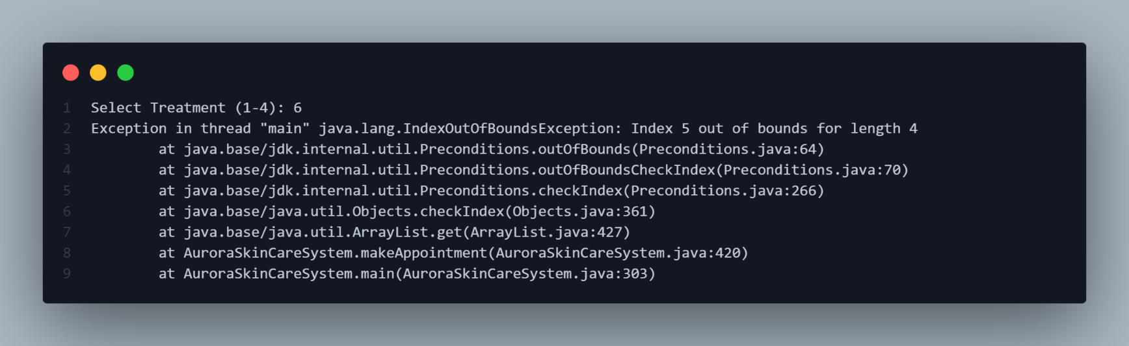

Figure 48 Error 02 - IndexOutOfBoundsException

**Solution:** To resolve this issue, the code was modified to validate the user's input and ensure that it falls within the valid range of treatment options *(Figure 49)*. This is achieved by using an if condition to check if the **treatmentChoice** is within the valid range (1 to **availableTreatments.size()**). If the input is invalid, an informative error message is displayed, and the method returns, preventing further execution with invalid input.

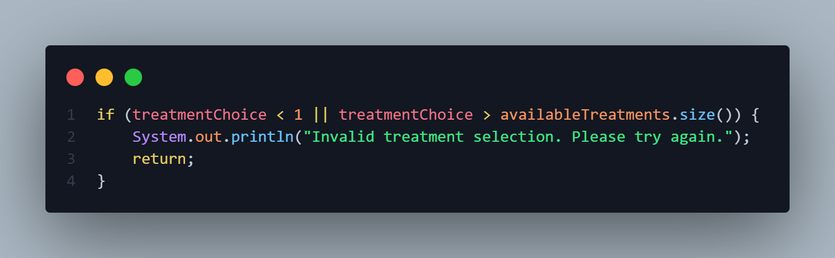

Figure 49 Solution 02 - Input Validation

With this solution, the program now displays a clear and informative error message *(Figure 50)* when the user enters an invalid treatment selection, guiding them to provide a correct input. This significantly improves the user experience and prevents the program from crashing due to unexpected input.

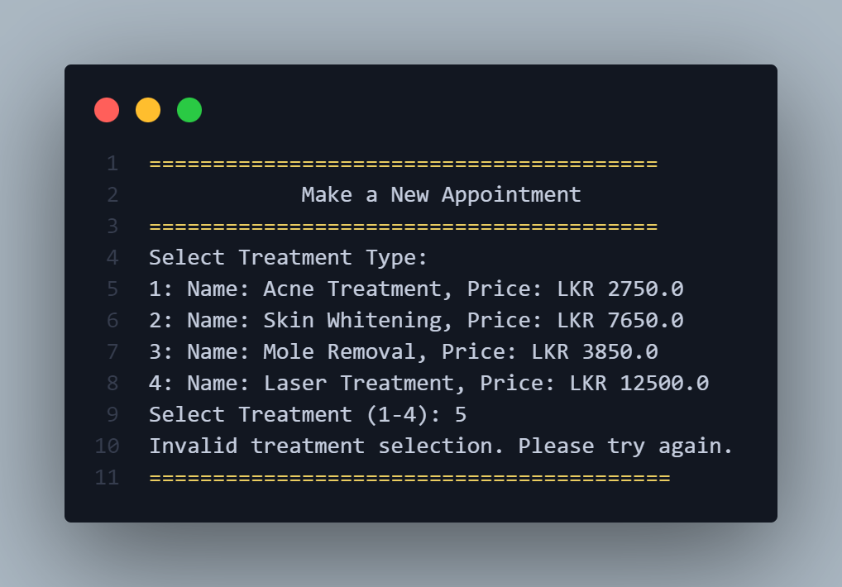

Figure 50 Output 02 - Informative Error Message

### InputMismatchException in Main Menu Selection

**Issue:** The application encountered an **InputMismatchException** *(Figure 51)* when the user provided invalid input, such as entering a string when an integer was expected. This error disrupted the program's flow and displayed an uninformative error message.

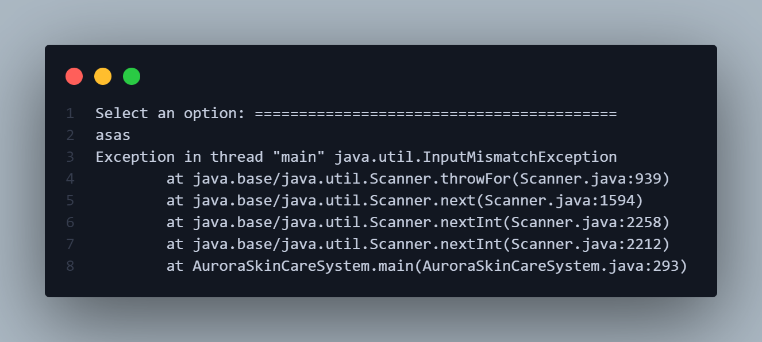

Figure 51 Error 03 - InputMismatchException

**Solution:** To resolve this issue, a **try-catch** block was implemented to gracefully handle the exception *(Figure 52)*. The try block attempts to read the user's input using **scanner.nextInt().** If an **InputMismatchException** arises, the catch block is executed, which prints a user-friendly error message and clears the invalid input from the input buffer. This ensures that the program can prompt the user for input again without causing further errors.

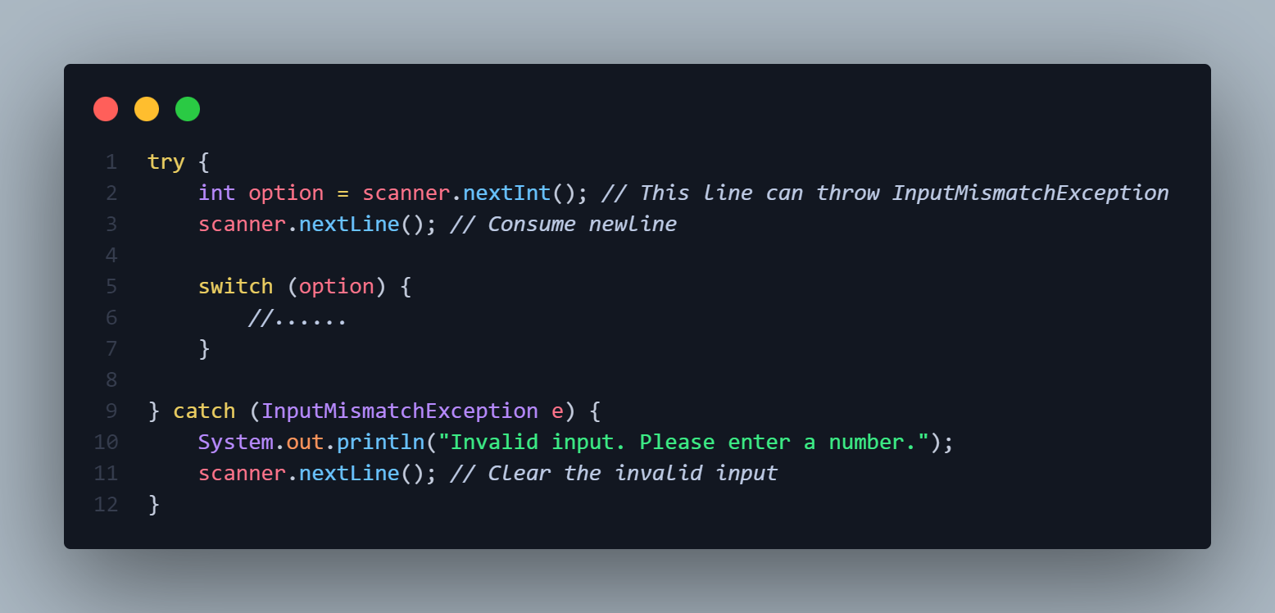

Figure 52 Solution 03 – Try-Catch Block

With this solution, the program now displays a clear and informative error message *(Figure 53)* when the user enters invalid input, guiding them to provide a correct input. This significantly improves the user experience and prevents the program from crashing due to unexpected input. 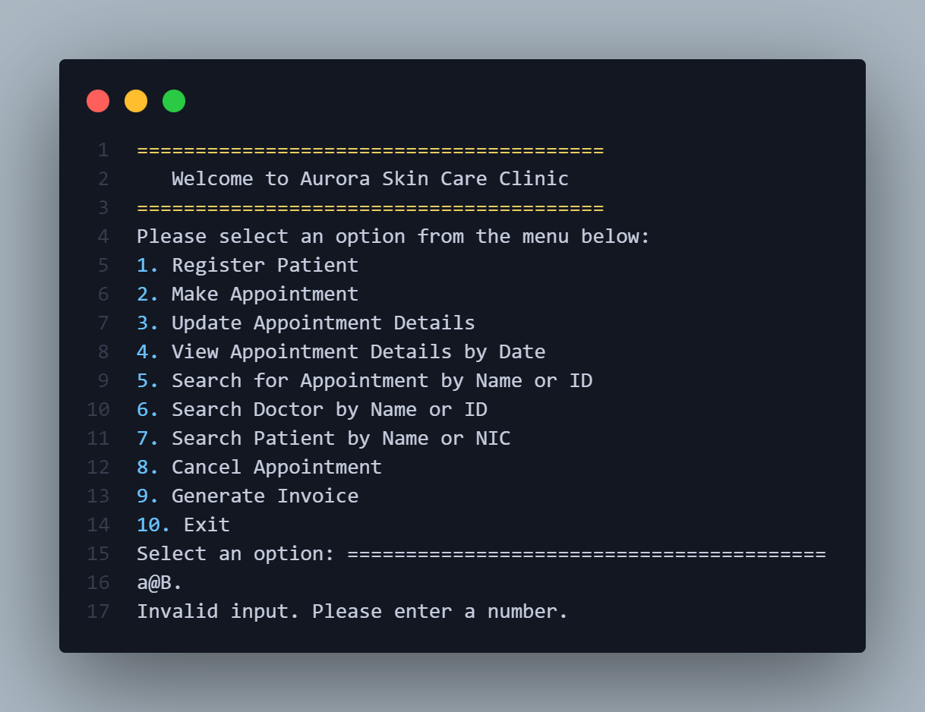

Figure 53 Output 03 - Informative Error Message

## Conclusion

The **Aurora Skin Care Clinic Management System** successfully integrates key functionalities to enhance patient and clinic interactions. Through effective management of patient registrations, appointment scheduling, treatment records, and payment processing, the system ensures a streamlined and user-friendly experience for both patients and clinic staff. Testing and validation have confirmed the system's ability to handle essential tasks such as booking appointments, generating invoices, updating patient records, and managing doctor schedules, demonstrating robustness and accuracy across multiple scenarios, including edge cases and invalid inputs.

**Project outcomes** include a fully functional console-based application that employs Object-Oriented Programming (OOP) principles, with well-structured classes and methods for each module. This structure allows for clear data flow and facilitates maintenance. The class diagram and underlying design decisions reflect a modular approach, promoting scalability for future enhancements, such as adding additional features or expanding into a GUI-based system.

**Limitations** identified during testing include constraints in appointment overlap management for high-demand doctors and limitations in handling complex payment structures, such as multi-session treatments or bundled services. Additionally, the system is currently console-based, which, while functional, may not provide the optimal user experience in a real-world scenario where a graphical interface would be beneficial.

## Future Enhancements

**1. Enhanced User Interface**

* **GUI Implementation:** Develop a user-friendly graphical user interface (GUI) to replace the current text-based interface. This will improve the overall user experience and make the system more accessible to a wider range of users.
* **Intuitive Navigation:** Design a clear and intuitive navigation system within the GUI to allow users to easily access different functionalities.

**2. Expanded Functionality**

* **Doctor Management:** Add features to manage doctor information, including scheduling, availability, and specialization.
* **Treatment Expansion:** Incorporate additional treatment options, including their details, pricing, and duration.
* **Flexible Appointment Scheduling:** Allow for more flexible appointment scheduling, including options for recurring appointments and multiple appointments per day.
* **Online Booking Integration:** Integrate an online booking system to enable patients to book appointments directly through a website or mobile app.

**3. Improved Error Handling and Input Validation**

* **Robust Error Handling:** Implement comprehensive error handling mechanisms to prevent system crashes and provide informative error messages to the user.
* **Input Validation:** Validate user input to ensure data integrity and prevent invalid data entry.

**4. Advanced Financial Tracking**

* **Detailed Financial Reports:** Generate detailed financial reports, including revenue, expenses, and profitability analysis.
* **Payment Integration:** Integrate with payment gateways to allow for online payments and secure transactions.
* **Inventory Management:** Track inventory levels of medical supplies and generate automated reordering alerts.

(OpenAI, 2024)

# Gantt Chart

|  |  |  |  |
| --- | --- | --- | --- |
| **Task** | **Start Date** | **End Date** | **Duration (Days)** |
| Requirements Gathering | 19/10/2024 | 25/10/2024 | 6 |
| System Design: Class Diagram | 26/10/2024 | 01/11/2024 | 6 |
| Coding & Development | 02/11/2024 | 07/11/2024 | 6 |
| Functional Testing | 08/11/2024 | 08/11/2024 | 1 |
| Documentation & Report | 09/11/2024 | 09/11/2024 | 1 |

Table 21 Gantt Chart

# References

OpenAI, 2024. *ChatGPT (November 2024 version) [Large language model].* [Online]   
Available at: https://www.openai.com/   
[Accessed 03 11 2024].